1. Introduction
   1. Introduction:

The Agro World system provides its users and researches to get online information about the crops, statistical details and increase products. Our Project (The Agro World) has been developed on PHP and MySQL. The Agro World System which will allow formal and informal Farmers, Wholesalers and Vendors to purchase and sell their products on the internet.

For the concept of ‘DIGITAL INDIA’ it is necessary to purchase or sell products online. So that website provides online shopping for users. It also has concept of “SUB-DOMAIN”. Using these concepts, Multiple Manufacturer and Multiple Sellers are connected with website.

For Examples,

mkisan.gov.in

User are able to search, purchase from both side.

The objective of this project is to create an e-farm web portal with a product retail price and quantities which would allow product information to be updated securely using a mobile device. The web portal will have an online interface in the form of an e-farm website that will allow users to buy goods from the Grocery Store.

There are multiple types of users available in the project:

1. Admin : With Full Access
2. Farmers : With Limited Access
3. Wholesaler : With Limited Access
4. Grocery Store : With Limited Access
5. Client : With Limited Access
   1. Project Profile:

|  |  |
| --- | --- |
| **Project Title** | The Agro World |
| **Company Name** | **ADITE Technologies** |
| **Development Tools** | WAMP Server |
| **Operating System** | Windows based Operating System |
| **Programming language and Scripting language** | PHP, HTML, CSS, JavaScript, JQuery |
| **Database** | MySQL |
| **Internal Guide** | Mr. Amit Hariyani |
| **External Guide** | Mr Vipul Jikadra |
| **Project Duration** | 15-Jan-2018 to 25-Apr-2018 |
| **Developed By** | Moradiya Sheetal V. |
| **Submitted To** | Department of Computer Science, Bhavnagar |

1. Company Profile

Company Profile:



1. Technologies Overview

**3.1 Macromedia Dreamweaver 8**

Macromedia Dreamweaver 8 is the industry-leading web development Tool, enabling users to efficiently design, develop and maintain Standards -based websites and applications.

Macromedia Dreamweaver is one of the most popular web-design programs in the industry. It allows you to develop professional websites and its user-friendly interface; tools and features have made it the must-have package for web designers.

Dreamweaver uses both Cascading Style Sheets (CSS) and Hyper Text Markup Language (HTML) and it has good code-editing support features that will help you to write the CSS and HTML. Alongside writing the code, you can use the visual layout tools to build your sites and make them look exceptional.

**3.2 PHP (Hypertext Pre-Processor)**

PHP is a scripting language originally designed for producing dynamic web pages. It has evolved to include a command line interface capability and can be used in standalone graphical applications.

While PHP was originally created by Rasmus Lerdorf in 1995, the main implementation of PHP is now produced by The PHP Group and serves as the defector standard for PHP as there is no formal specification. PHP is free software released under the PHP License; however it is incompatible with the GNU General Public License (GPL), due to restrictions on the usage of the term PHP.

PHP is a widely-used general-purpose scripting language that is especially suited for web development and can be embedded into HTML. PHP has grown from simple beginnings to a full-fledged Object Oriented language that can run both windows and UNIX/Linux platforms. The main advantage of using PHP over other platforms, such as Java or .Net, are that it is smaller, much simpler to install, and more lightweight, needing only a fraction of the memory of the Java Runtime of the .Net CLR. Since it is an open source language and we do not have to purchase it, it seemed best choice for the development of our project as we had to maintain a very low budget throughout out project.

* **Features of PHP**

The following features of PHP are

* Simplicity
* Portability
* Speed
* Open Source
* Extensible
* XML and Database Support

**3.3 JavaScript**

JavaScript is a scripting language used to enable programmatic access to objects within other applications. It was developed by Brendan Eich.

It is primarily used in the form of client-side JavaScript for the development of dynamic websites. JavaScript is a dialect of the ECMAScript standard and is characterized as a dynamic, weakly typed, prototype-based language with first-class functions. JavaScript was influenced by many languages and was designed to look like Java, but be easier for non-programmers to work with.

JavaScript, despite the name, is essentially unrelated to the Java programming language even though the two do have superficial similarities. Both languages use syntaxes influenced by that of C syntax, and JavaScript copies many Java names and naming conventions. The language's name is the result of a co-marketing deal between Netscape and Sun, in exchange for Netscape bundling Sun's Java runtime with their then-dominant browser. The key design principles within JavaScript are inherited from the self and Scheme programming languages.

"JavaScript" is a trademark of Sun Microsystems. It was used under license for technology invented and implemented by Netscape Communications and current entities such as the Mozilla Foundation.

**3.4 CSS (Cascading Style Sheets)**

Cascading Style Sheets (CSS) is a style sheet language used to describe the presentation (that is, the look and formatting) of a document written in a markup language. It’s most common application is to style web pages written in HTML and XHTML, but the language can be applied to any kind of XML document, including SVG and XUL.

CSS is designed primarily to enable the separation of document content (written in HTML or a similar markup language) from document presentation, including elements such as the colors, fonts, and layout. This separation can improve content accessibility, provide more flexibility and control in the specification of presentation characteristics, enable multiple pages to share formatting, and reduce complexity and repetition in the structural content (such as by allowing for table less web design). CSS can also allow the same markup page to be presented in different styles for different rendering methods, such as on-screen, in print, by voice (when read out by a speech-based browser or screen reader) and on Braille-based, tactile devices.

**3.5 MySQL**

MySQL is a high-performance, multiuser relational database management system for database driven software applications.

Designed around three fundamental principles-speed, stability and ease of use, and freely available under the GNU (General Public License). MySQL has been dubbed “the world’s most popular open-source database “by its parent company, MySQL AB.

Today, MySQL is available for a wide variety of platforms, including Linux, MacOS and Windows.

* **Features of MySQL**

The following features of MySQL are

* Speed
* Reliability
* Security
* Scalability and Portability
* Ease of Use
* Compliance with Existing Standards
* Wide Application Support
* Easy Licensing Policy

1. System Analysis

System Analysis:

Systems analysis is a problem solving technique that decomposes a system into its component pieces for the purpose of the studying how well those component parts work and interact to accomplish their purpose.

Analysis is the detailed study of various operations performed by the system and their relationship within and outside of the system. The goal of this phase is to understand the exact requirements of the System. The requirements describe the ‘what’ of a system not the ‘how’.

* Existing System:

The Agro world currently use a manual system for the sell and purchase products by farmers, wholesaler and grocery store.

* **Limitations of Existing System:**
* Database systems are complex, difficult, and time-consuming to design
* Substantial hardware and software start-up costs
* Damage to database affects virtually all applications programs
* Extensive conversion costs in moving form a file-based system to a database system
* Initial training required for all programmers and users
* Proposed System:
  + User can register them self and purchase products from grocery stores.
  + They can login to the system and manage their personal information through the system.
  + Farmer, Wholesaler, Grocery Store users are manage their products and also sell or purchase products on website.

1. System Design

System Design:

Systems design is the process of defining the architecture, components, modules, interfaces, and data for a system to satisfy specified requirements. Systems design could be seen as the application of systems theory to product development.

During system design, there is initially a need to explore alternative technical solutions. Once a technical alternative is chosen and approved, the system design phase develops the technical blueprints and specifications required to implement the final solution. These blueprints and specifications will be used to implement required databases, programs, user interfaces, and networks for the information system.

* 1. Modules:

We are following the divide and conquer theory, so divide the overall problem into more manageable parts and develop each part or module separately. All modules are ready, to integrate all the modules into one system. In this phase, we could briefly describe all the modules and the functionality of these modules.

There are two types of users available in the project:

1. Admin : With Full Access
2. Farmers : With Limited Access
3. Wholesaler : With Limited Access
4. Grocery Store : With Limited Access
5. Client : With Limited Access

**Functionality Performed by Admin:**

* Login
* Main Category Management
* Sub Category Management
* Farmer Management
* Wholesaler Management
* Grocery Store Management
* Inquiry Management
* Logout

**Functionality Performed by Farmer:**

* Register
* Login
* Profile Management
* Upload Products
* Invoice
* Logout

**Functionality Performed by Wholesaler:**

* Register
* Login
* Profile Management
* Upload Products (Sell)
* Purchase Products From Farmer (Buy)
* Invoice
* Logout

**Functionality Performed by Grocery Store:**

* Register
* Login
* Profile Management
* Upload Products (Sell)
* Purchase Products From Wholesaler (Buy)
* Invoice
* Logout

**Functionality Performed by User:**

* Register
* Login
* Profile Details
* Purchase From Grocery Store
* My Cart
* Inquiry
* Logout

Here, explanation of Admin and Client modules in Detail.

1. **Admin : With Full Access**

* **Login**

Admin can login with Username and Password.

If user enters the wrong username or password then website cannot allow to access and also display the message to user “Username and Password not match” otherwise user can access the website.

* **Change Password**

Admin can change password or set new password.

* **Manage Category**

Admin can insert, delete and display data for various categories like Farmer, Wholesaler, and Grocery Stores’.

* **Manage Main Products**

Admin can insert, delete, update and display data for various Products like Fruits, Vegetables, and Grains etc. Farmer, Wholesaler, Grocery Stores’.

* **Manage Sub-Products**

Admin can insert, delete, update and display data for various Product’s sub products like Apple, Banana, Wheat, Rice, etc. for Farmer, Wholesaler, Grocery Stores.

* **Manage Gallery**

Admin can insert, delete, update and display data for various Products gallery images Farmer, Wholesaler, Grocery Stores’.

* **Manage Customers**

Customer can register in The Agro World website after admin can display and delete customer’s data.

* **Manage Sub User**

Admin can insert, delete, update and display data for various Sub Users.

* **Manage Inquiry**

Admin and Sub-admin can display and delete inquiry data and also send positive reply to the customer.

* **Logout**

Admin and Sub-admin can logout

1. **Farmer : With Limited Access**
   * + **Register**

Farmer Can Register With Their Information

* + - **Login**

Farmer can login with their login id and password

* + - **Profile Management**

They also manage their profile with login

* + - **Manage Purchase Request From Wholesaler**

Farmer can manage request from wholesaler

* + - **Logout**

Farmer Can Logout

1. .**Wholesaler : With Limited Access**
   * + **Register**

Wholesaler Can Register With Their Information

* + - **Login**

Wholesaler can login with their login id and password

* + - **Profile Management**

They also manage their profile with login

* + - **Manage Purchase Request From Wholesaler**

Wholesaler can manage request from Grocery Store

* + - **Logout**

Wholesaler Can Logout

1. **Grocery Store : With Limited Access**
   * + **Register**

Vendors Can Register With Their Information

* + - **Login**

Vendors can login with their login id and password

* + - **Profile Management**

They also manage their profile with login

* + - **Manage Purchase Request From Wholesaler**

Vendors can manage request from User

* + - **Logout**

Vendors Can Logout

1. **Client : With Limited Access**

* **Registration**

User can register with Agro website for purchase Products. User can register then admin can give permission to purchase products.

* **Login**

User can login with Username and Password.

If user enters the wrong username or password then software cannot allow to access and also display the message to user “Username and Password not match” otherwise user can access the website.

* **Change Password**

User can change password or set new password.

* **Manage Products**

User can display data for various products products like Grains, Fruits Vegetables, etc. for Farmer, Wholesaler, Grocery Store.

* **My Cart**

User can purchase products then it display data in my cart.

* **Manage Inquiry**

User can send inquiry to the admin for positive reply and for Products inquiry.

* **Contact Us**

Contact Us Page contains the details of the Contact with quick inquiry.

* **Logout**

Users can logout.

* 1. Database Design (Data Dictionary):

Data design will consist of how we organize, managing and manipulate the data.

A Database Design is a catalogue, a repository of the element system. As the name suggest the element center on the data and they are structures to meet use requirement and organization needs. Thus data dictionary gives the details and description of the data flow, process and store used in data diagram.

* **Import of data in Database: -**
* To manage the details in large system.
* To communicate a common meaning for all elements.
* To document the feature of the system.
* To facilitate analysis of the details in order to evaluate characteristics and determine where system change should be made.
* To locate errors and omissions in the system.

**Database: db_agro**

* **[1] tbl_admin**

|  |  |  |  |
| --- | --- | --- | --- |
| Field Name | Datatype | Length | Remark |
| a_id | Integer | 11 | Primary Key |
| login_id | Varchar | 20 | Admin Login ID |
| Password | Varchar | 15 | Admin Password |
| Name | Varchar | 15 | Name |
| Email | Varchar | 35 | Email ID |
| mobile | Integer | 10 | Mobile No |
| a_photo | Varchar | 100 | Picture |
| Flag | Integer | 1 |  |

* **[2] tbl_farmer**

|  |  |  |  |
| --- | --- | --- | --- |
| Field Name | Datatype | Length | Remark |
| f_id | Integer | 11 | Primary Key |
| f_login | Varchar | 20 | Farmer Login ID |
| Password | Varchar | 15 | Farmer Password |
| Fname | Varchar | 15 | Farmer name |
| Faddress | Varchar | 255 | Farmer Address |
| State | Varchar | 15 | State name |
| City | Varchar | 15 | City Name |
| pincode | Integer | 6 | Pin code |
| mobile | Integer | 10 | Mobile No |
| details | varchar | 50 | Details of farmer |
| Email | varchar | 35 | Email ID |
| f_pic | varchar | 100 | Pic of Farmer |
| Flag | Integer | 1 |  |

* **[3] tbl_wholesaler**

|  |  |  |  |
| --- | --- | --- | --- |
| Field Name | Datatype | Length | Remark |
| w_id | integer | 11 | Primary Key |
| w_login | varchar | 20 | Wholesaler Login ID |
| Password | varchar | 15 | Wholesaler Password |
| Wname | varchar | 15 | Whole Saler name |
| shop_name | varchar | 15 | Shop Name |
| shop_address | varchar | 255 | Shop Address |
| Pincode | integer | 6 | Pin code |
| Mobile | integer | 10 | Mobile No |
| Details | varchar | 50 | Details of farmer |
| Email | varchar | 35 | Email ID |
| w_pic | varchar | 100 | Pic of Wholesaler |
| Flag | integer | 1 |  |

* **[4] tbl_grocerystore**

|  |  |  |  |
| --- | --- | --- | --- |
| Field Name | Datatype | Length | Remark |
| g_id | integer | 11 | Primary Key |
| g_login | varchar | 20 | Store Login ID |
| Password | varchar | 15 | Store Password |
| Gname | varchar | 15 | Store name |
| Gaddress | varchar | 255 | Store Address |
| Pincode | integer | 6 | Pin code |
| Mobile | integer | 10 | Mobile No |
| Details | varchar | 50 | Details of farmer |
| Email | varchar | 35 | Email ID |
| Flag | integer | 1 |  |

* **[5] tbl_user**

|  |  |  |  |
| --- | --- | --- | --- |
| Field Name | Datatype | Length | Remark |
| u_id | integer | 11 | Primary Key |
| u_login | varchar | 20 | User ID |
| Password | varchar | 15 | User Password |
| Uname | varchar | 15 | User name |
| Uaddress | varchar | 255 | User Address |
| Pincode | integer | 6 | Pin code |
| Mobile | integer | 10 | Mobile No |
| Details | varchar | 50 | Details of farmer |
| Email | varchar | 35 | Email ID |
| Flag | integer | 1 |  |

* **[6] tbl_main_cat**

|  |  |  |  |
| --- | --- | --- | --- |
| Field Name | Datatype | Length | Remark |
| Mid | integer | 11 | Primary Key |
| mc_name | varchar | 30 | Main Category Name |
| pic_mcat | varchar | 100 | Main Category Pic |
| Flag | integer | 1 |  |

* **[7] tbl_sub_cat**

|  |  |  |  |
| --- | --- | --- | --- |
| Field Name | Datatype | Length | Remark |
| Sid | integer | 11 | Primary Key |
| mc_name | varchar | 30 | main Category Name |
| sc_name | varchar | 30 | Sub Category Name |
| pic_scat | varchar | 100 | Sub Category Pic |
| Flag | integer | 1 |  |

* **[8] tbl_products_farmer**

|  |  |  |  |
| --- | --- | --- | --- |
| Field Name | Datatype | Length | Remark |
| Pfid | integer | 11 | Primary Key |
| mc_name | varchar | 30 | Main Category Name |
| sc_name | varchar | 30 | Sub Category Name |
| Qty | integer | 10 | Quantity |
| Rate | integer | 8 | Rate |
| weight_type | varchar | 50 | Type |
| Date | varchar | 11 | Date |
| Desc | varchar | 100 | Description |
| pic1 | varchar | 100 | Pic of Product |
| pic2 | varchar | 100 | Pic of Product |
| pic3 | varchar | 100 | Pic of Product |
| Flag | integer | 1 |  |

* **[9] tbl_products_wholesaler**

|  |  |  |  |
| --- | --- | --- | --- |
| Field Name | Datatype | Length | Remark |
| Pwid | integer | 11 | Primary Key |
| mc_name | varchar | 30 | Main Category Name |
| sc_name | varchar | 30 | Sub Category Name |
| Qty | integer | 10 | Quantity |
| Rate | integer | 8 | Rate |
| weight_type | varchar | 50 | Type |
| Date | varchar | 11 | Date |
| Desc | varchar | 100 | Description |
| pic1 | varchar | 100 | Pic of Product |
| pic2 | varchar | 100 | Pic of Product |
| pic3 | varchar | 100 | Pic of Product |
| Flag | integer | 1 |  |

* **[10] tbl_products_grocerystore**

|  |  |  |  |
| --- | --- | --- | --- |
| Field Name | Datatype | Length | Remark |
| Pgtid | integer | 11 | Primary Key |
| mc_name | varchar | 30 | Main Category Name |
| sc_name | varchar | 30 | Sub Category Name |
| Qty | integer | 10 | Quantity |
| Rate | integer | 8 | Rate |
| weight_type | varchar | 50 | Type |
| Date | varchar | 11 | Date |
| Desc | varchar | 100 | Description |
| pic1 | varchar | 100 | Pic of Product |
| pic2 | varchar | 100 | Pic of Product |
| pic3 | varchar | 100 | Pic of Product |
| Flag | integer | 1 |  |

* **[11] invoice_farmer**

|  |  |  |  |
| --- | --- | --- | --- |
| Field Name | Datatype | Length | Remark |
| Ifid | integer | 11 | Primary Key |
| mc_name | varchar | 30 | Main Category Name |
| sc_name | varchar | 30 | Sub Category Name |
| wholeseller_name | varchar | 15 | Whole saler Name |
| shop_name | varchar | 15 | Shop Name |
| shop_address | varchar | 255 | Shop Address |
| Date | varchar | 11 | Date |
| Qty | integer | 10 | Quantity |
| Rate | integer | 8 | Rate |
| weight_type | varchar | 50 | Type |
| Discount | integer | 8 | Discount |
| Gst | integer | 3 | GST |
| net_amount | integer | 10 | Net Amount |
| email | varchar | 35 | Email ID |
| mobile | integer | 10 | Mobile No |
| Flag | integer | 1 |  |

* **[12] invoice_wholesaler**

|  |  |  |  |
| --- | --- | --- | --- |
| Field Name | Datatype | Length | Remark |
| Iwid | integer | 11 | Primary Key |
| mc_name | varchar | 30 | Main Category Name |
| sc_name | varchar | 30 | Sub Category Name |
| grocerystore | varchar | 15 | Grocery Store Name |
| shop_address | varchar | 255 | Shop Address |
| Date | varchar | 11 | Date |
| Qty | integer | 10 | Quantity |
| Rate | integer | 8 | Rate |
| weight_type | varchar | 50 | Type |
| Discount | integer | 8 | Discount |
| Gst | integer | 3 | GST |
| net_amount | integer | 10 | Net Amount |
| email | varchar | 35 | Email ID |
| mobile | integer | 10 | Mobile No |
| Flag | integer | 1 |  |

* **[13] invoice_grocerystore**

|  |  |  |  |
| --- | --- | --- | --- |
| Field Name | Datatype | Length | Remark |
| Igid | integer | 11 | Primary Key |
| mc_name | varchar | 30 | Main Category Name |
| sc_name | varchar | 30 | Sub Category Name |
| Uname | varchar | 15 | User name |
| Uaddress | varchar | 255 | User Address |
| Date | varchar | 11 | Date |
| Qty | integer | 10 | Quantity |
| Rate | integer | 8 | Rate |
| weight_type | varchar | 50 | Type |
| Discount | integer | 8 | Discount |
| Gst | integer | 3 | GST |
| net_amount | integer | 10 | Net Amount |
| email | varchar | 35 | Email ID |
| mobile | integer | 10 | Mobile No |
| flag | integer | 1 |  |

* **[14] inquiry_mgmt**

|  |  |  |  |
| --- | --- | --- | --- |
| Field Name | Datatype | Length | Remark |
| Iid | integer | 11 | Primary Key |
| Name | varchar | 15 | Name |
| Address | varchar | 255 | Address |
| Pincode | vachar | 6 | Pincode |
| Mobile | varchar | 14 | Mobile No. |
| Email | varchar | 35 | Email ID. |
| Comments | varchar | 255 | Comments |
| Flag | integer | 1 |  |

* **[15] tbl_state**

|  |  |  |  |
| --- | --- | --- | --- |
| Field Name | Datatype | Length | Remark |
| Sid | integer | 11 | Primary Key |
| s_name | varchar | 20 | State Name |
| Flag | integer | 1 |  |

* **[16] tbl_city**

|  |  |  |  |
| --- | --- | --- | --- |
| Field Name | Datatype | Length | Remark |
| cid | integer | 11 | Primary Key |
| s_name | varchar | 20 | State Name |
| c_name | varchar | 20 | City Name |
| Flag | integer | 1 |  |

* **[17] gallery**

|  |  |  |  |
| --- | --- | --- | --- |
| Field Name | Datatype | Length | Remark |
| Gid | integer | 11 | Primary Key |
| pic_name | varchar | 100 | State Name |
| Gpic | varchar | 100 | City Name |
| Flag | integer | 1 |  |

* 1. Use Case Diagram:

A use case diagram at its simplest is a representation of a user's interaction with the system that shows the relationship between the user and the different use cases in which the user is involved. A use case diagram can identify the different types of users of a system and the different use cases and will often be accompanied by other types of diagrams as well.

* Use Case Diagram of Admin, Farmer, Wholesaler, Grocery Store :

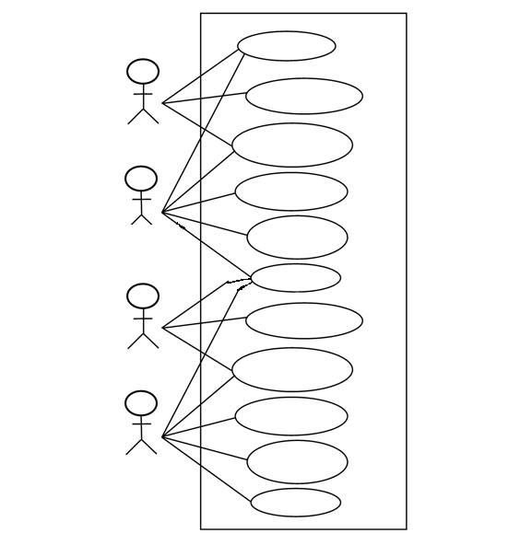

* **Admin**
* Use Case Diagram of Admin:

Admin

* **Farmer**

Farmer

* **Wholesaler**

Wholesaler

* **Grocery Store**

Grocery

* **User**

User

* 1. Activity Diagram:

Activity Diagram used to show describe dynamic aspects of the system. Activity diagram is basically a flow chart to represent the flow from one activity to another activity.

The Activity can be described as an operation of the system. So the control flow is drawn from one operation to another.

It represents flow of control in system. So it is consist of activity and link. This flow can be single or group.

**Activity Diagram of End User**

Yes

Data save to Database

Register as New User

Visit Website

Error Message

No

Fill require field

**Activity Diagram of Registered User**

Visit Website

View Profile

Yes

Error Message

No

Success

Login

Logout

My Cart

Invoice

Buy Product

Search Products

**Activity Diagram of Admin**

Add

Edit

View

Logout

Product

Yes

Error Message

No

Success

Login

Delete

View

Inquiry

Users

Delete

Gallery

Grocery

Farmer

Wholesaler

**Activity Diagram of Farmer / Wholesaler / Grocery Users**

View Profile

Yes

No

Error Message

Success

Login

Edit

Delete

View

View Invoice

Manage Products

Edit Profile

Logout

Add

**Activity Diagram of Users**

Yes

No

Error Message

Success

Login

Logout

My Cart

Buy

Search Products

View Products

1. Screen Shots

**ADMIN**

**Admin Login**

Admin can able to login into the website using login id and password

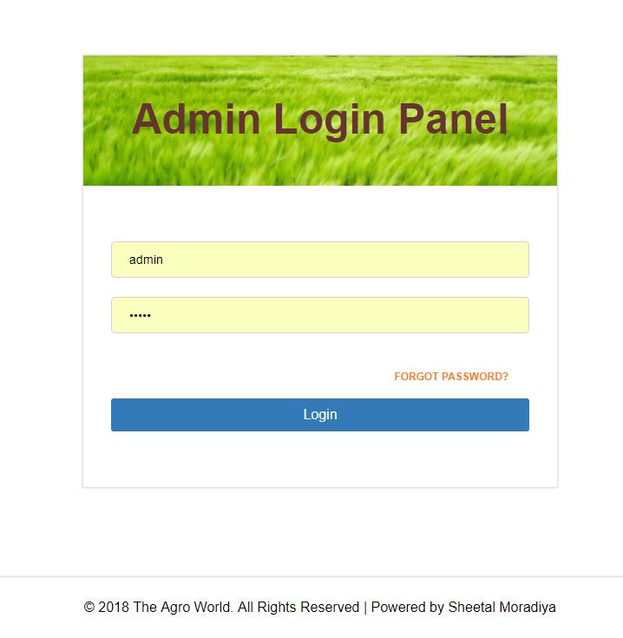

**Wrong Login id or Password**

If admin enter wrong login id or password then it display message.

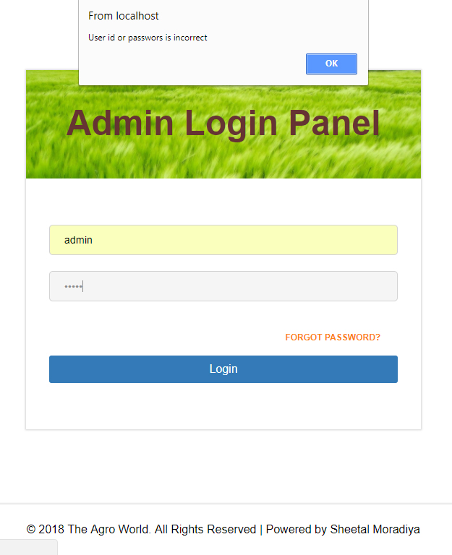

**Admin Home**

Admin home page.

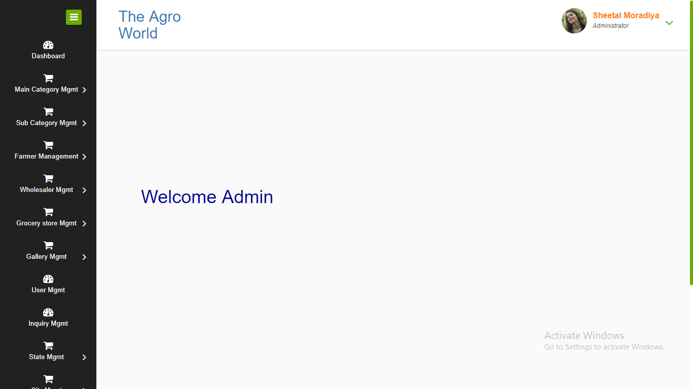

**Add Product Category**

Admin can able to add name of main category. Other users like farmer, wholesaler etc. can able to add products data based on main category.

For example, Fruits, Vegetables, Rice etc.

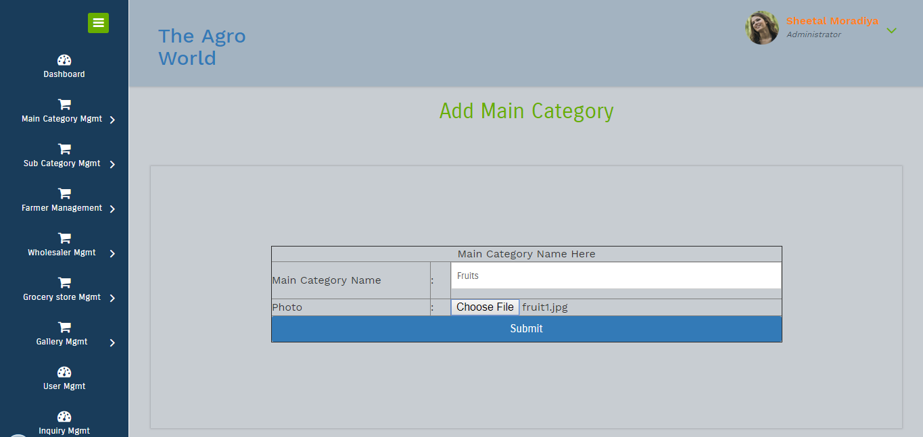

**Display Product Categories**

It display product categories which are entered by admin.

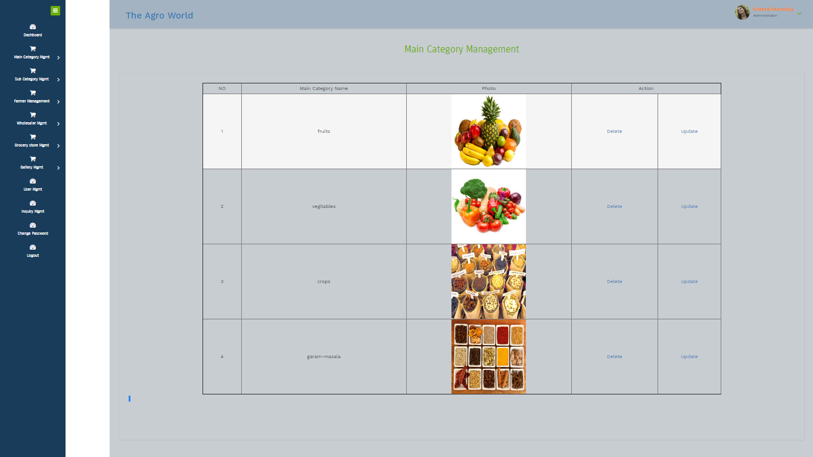

**Add Sub Category of Product**

Admin can able to enter sub category information of product for example fruits – banana, fruits – orange, vegetables – cabbage, rice – basmati rice etc..

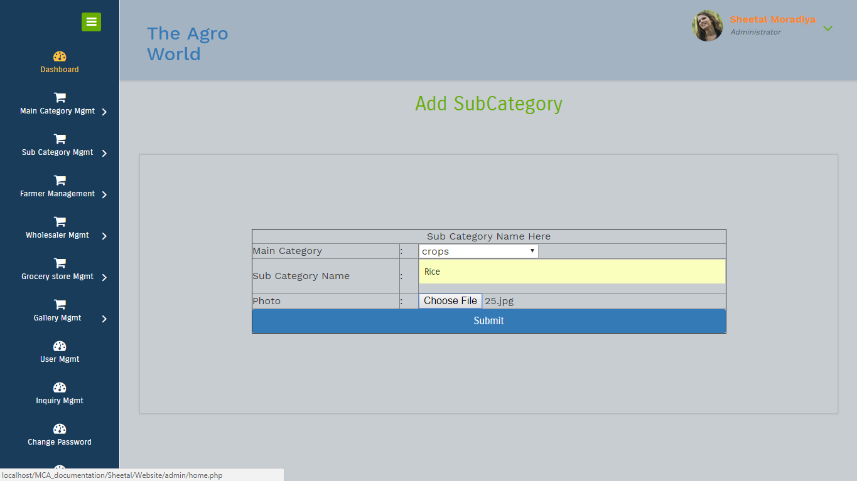

**Display Sub Category Information or data**

It display data which are entered by admin.

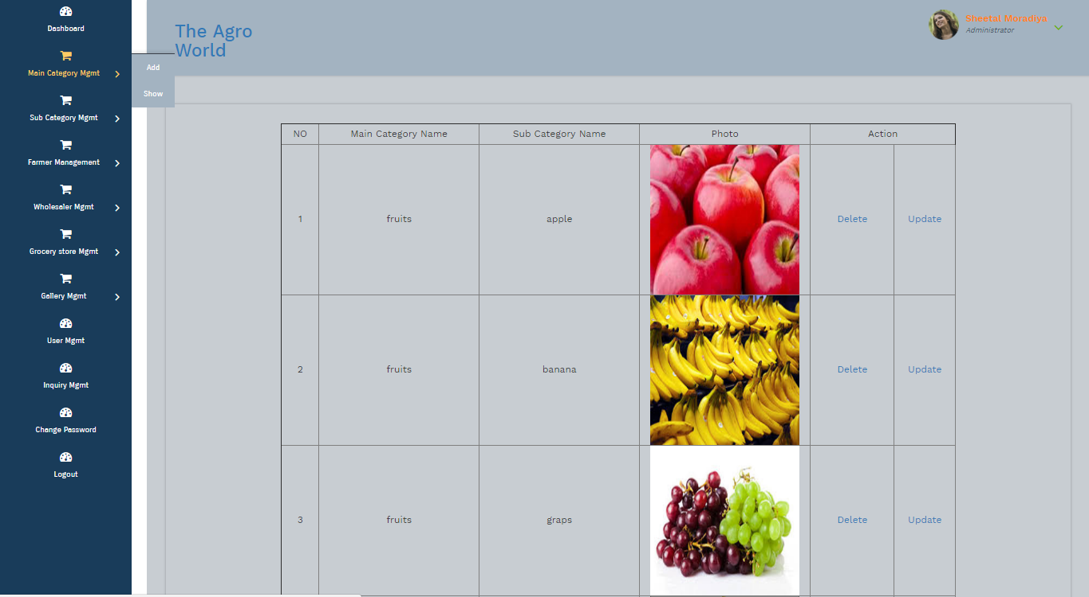**Add Farmer information**

Admin can able to add farmer.

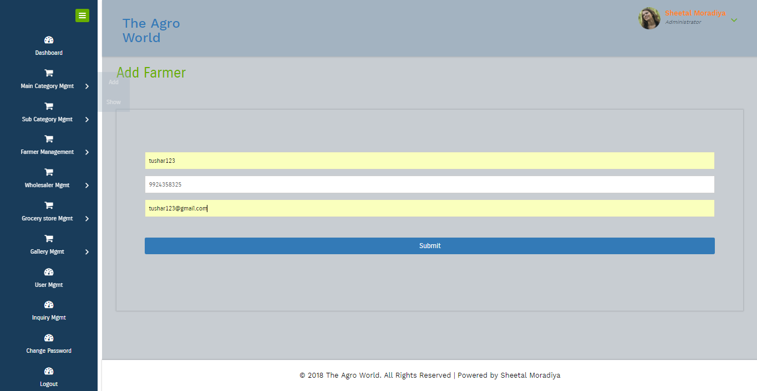

**Show farmers.**

Display farmer data which are entered by admin.

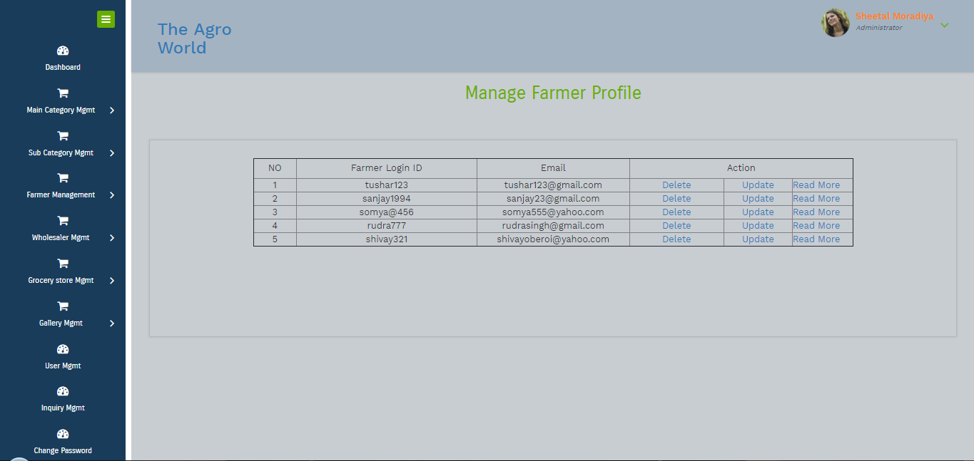

**Edit Farmer**

Admin can able to edit farmer information.

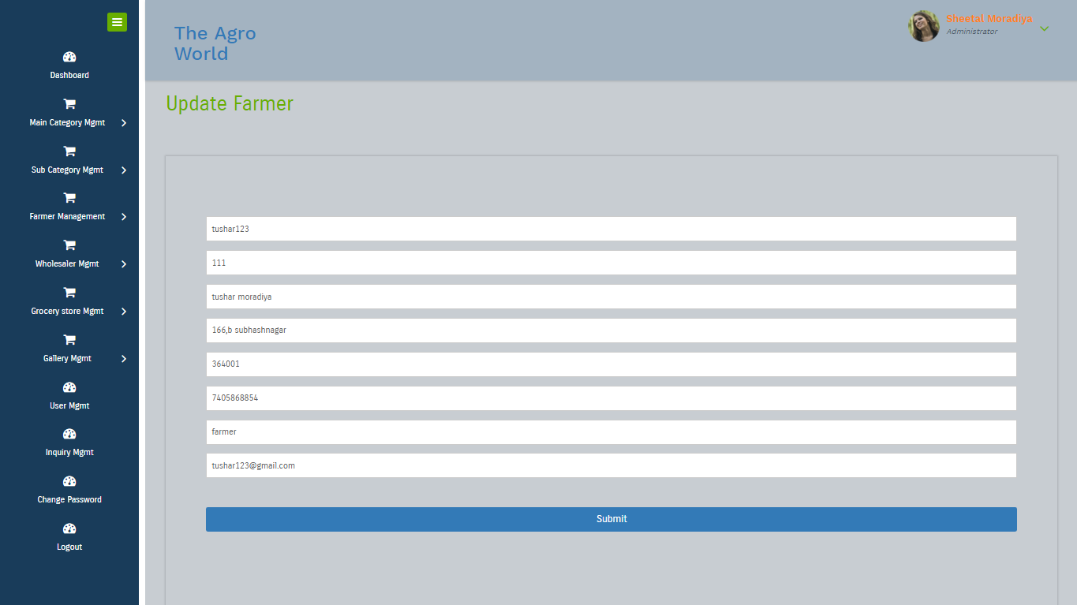

**Add wholesalers**

Admin can able to add wholesaler information.

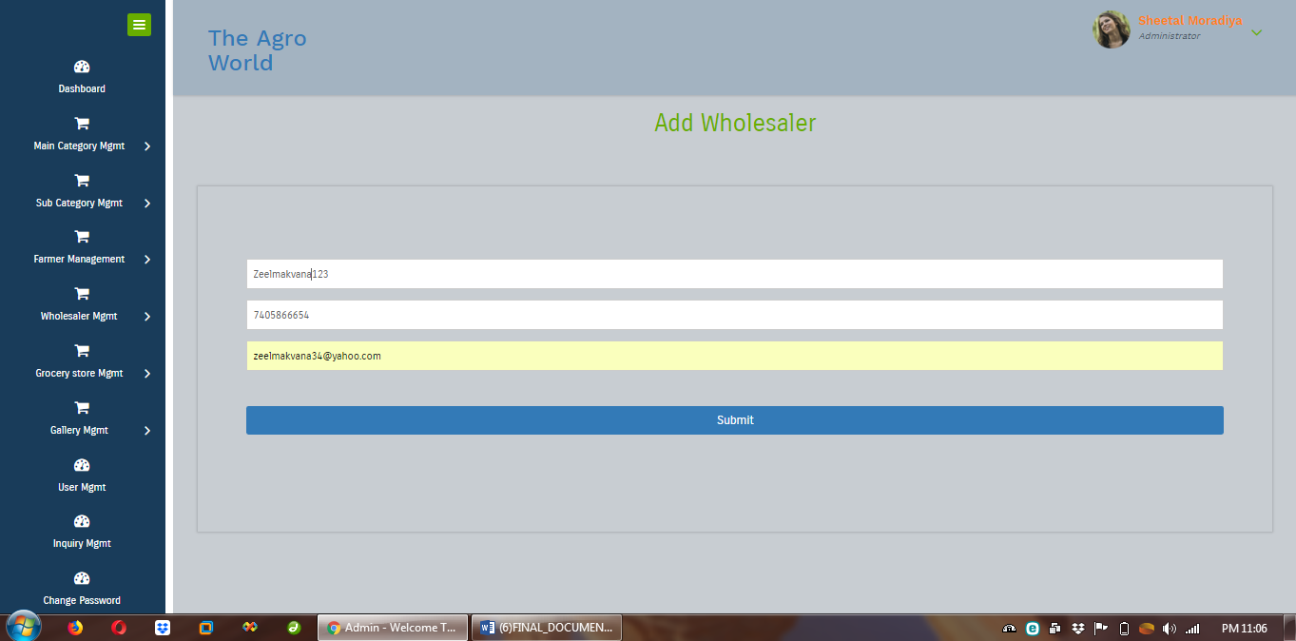

**Show wholesalers**

Display wholesaler data which are entered by admin.

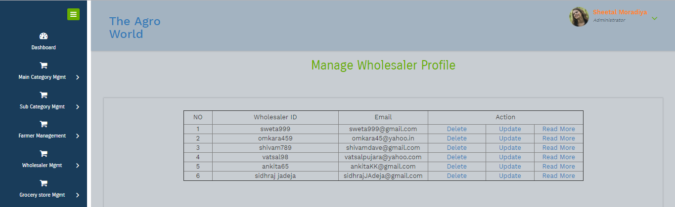

**Edit wholesaler**

Admin can able to edit wholesaler data.

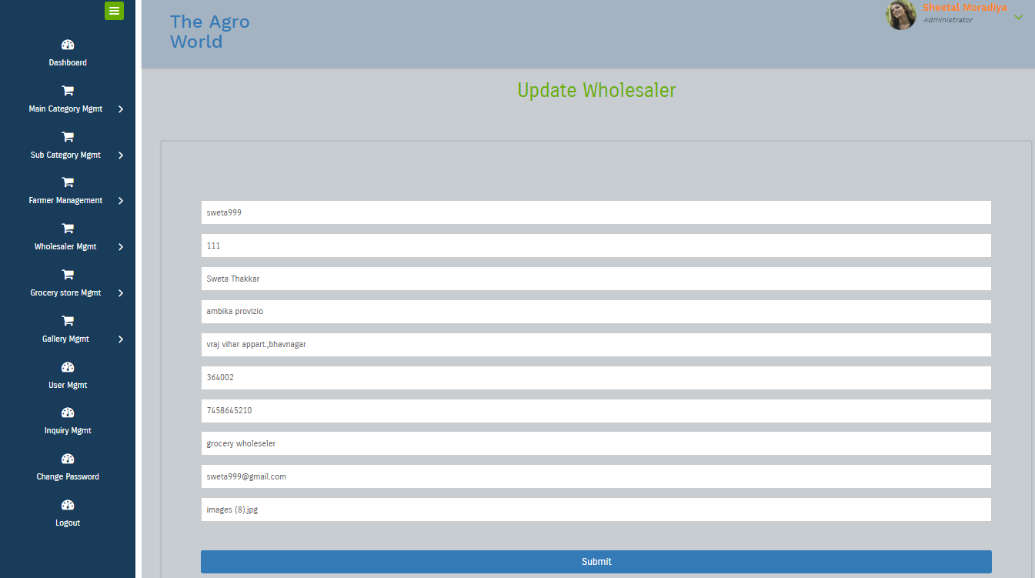

**Show Wholesaler profile**

Admin can able to show wholesaler data.

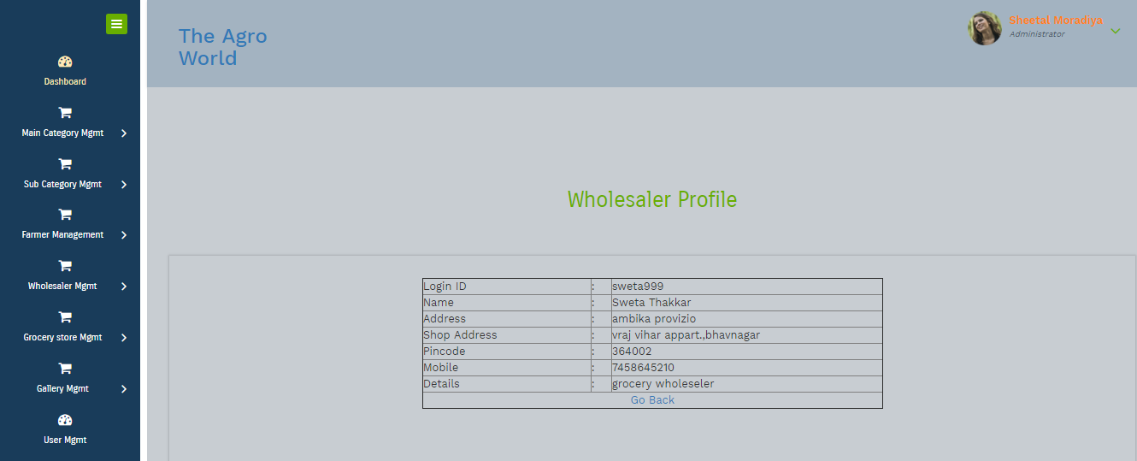

**Add Grocery information**

Admin can able to add grocery user data.

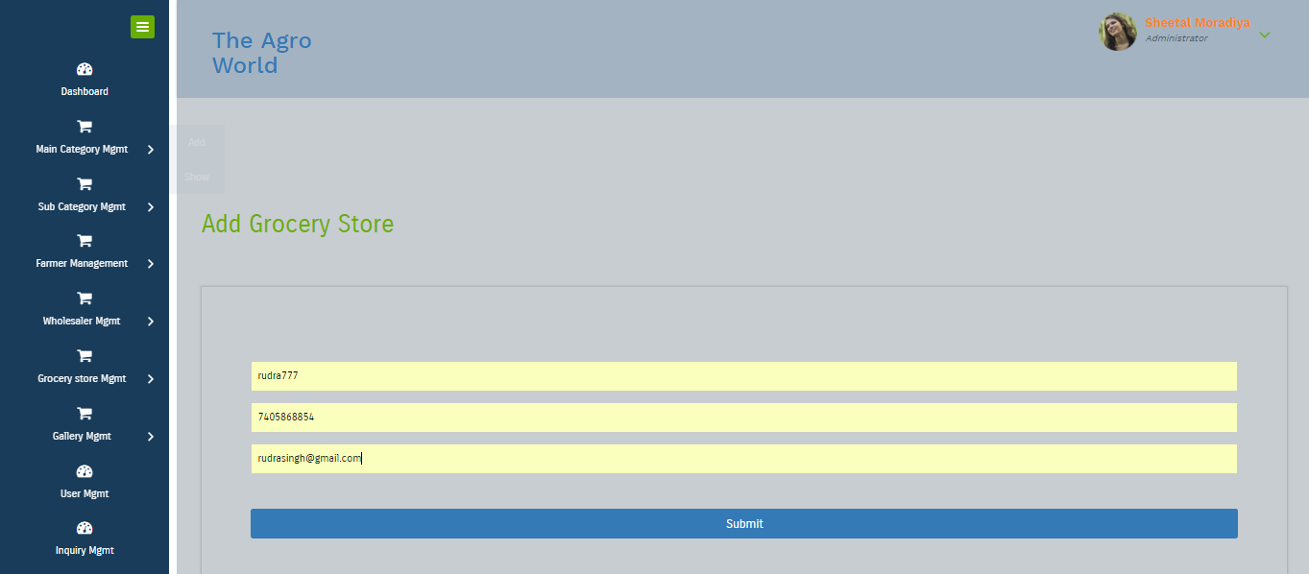

**Show Grocery store users.**

Admin can able to view grocery user’s data.

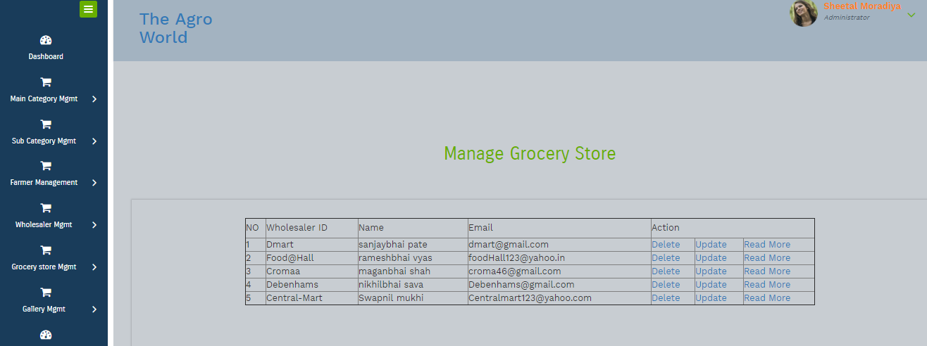

**Edit Grocery Store User Data.**

Admin can able to edit grocery store user data or information.

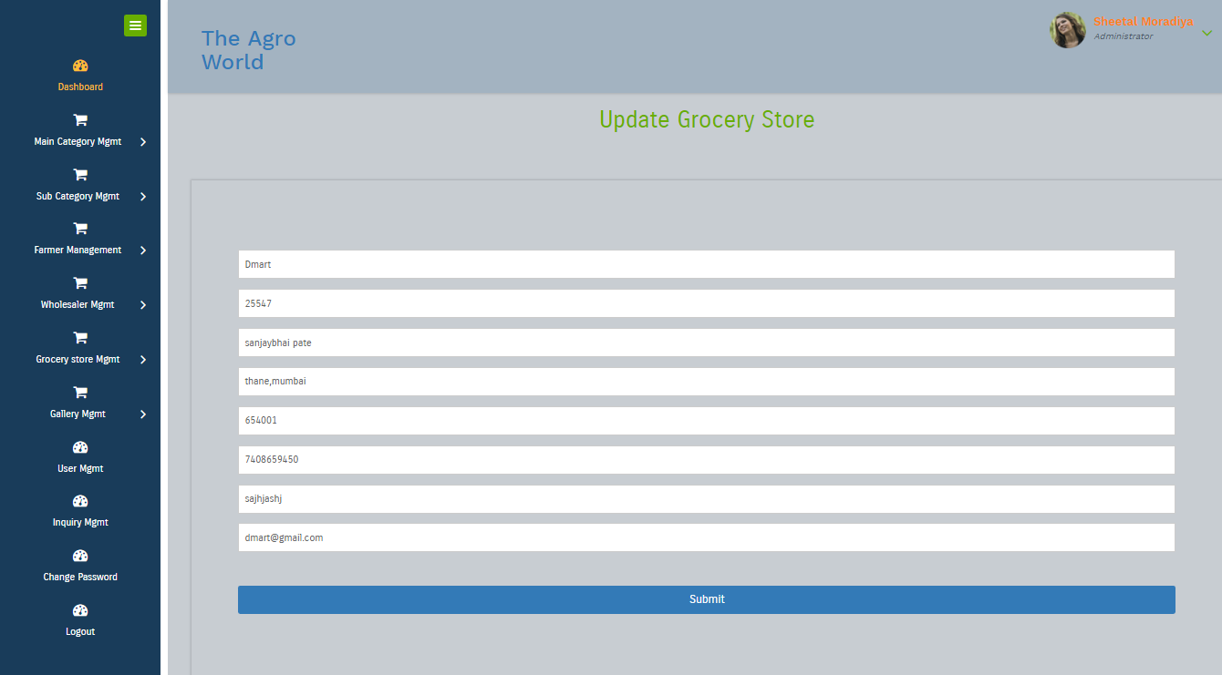

**Add Images to Gallery**

Admin can able to add images for gallery.

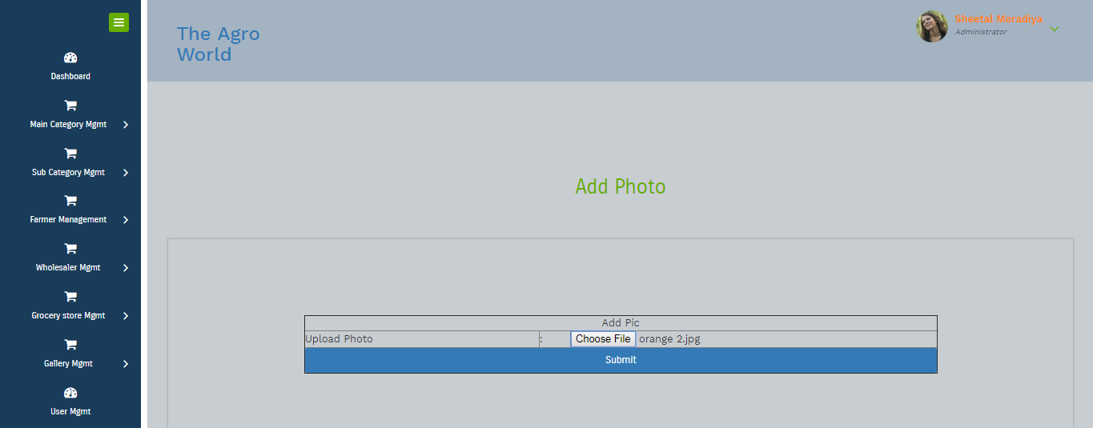

**View Gallery Images**

Admin can able to view and delete images of gallery.

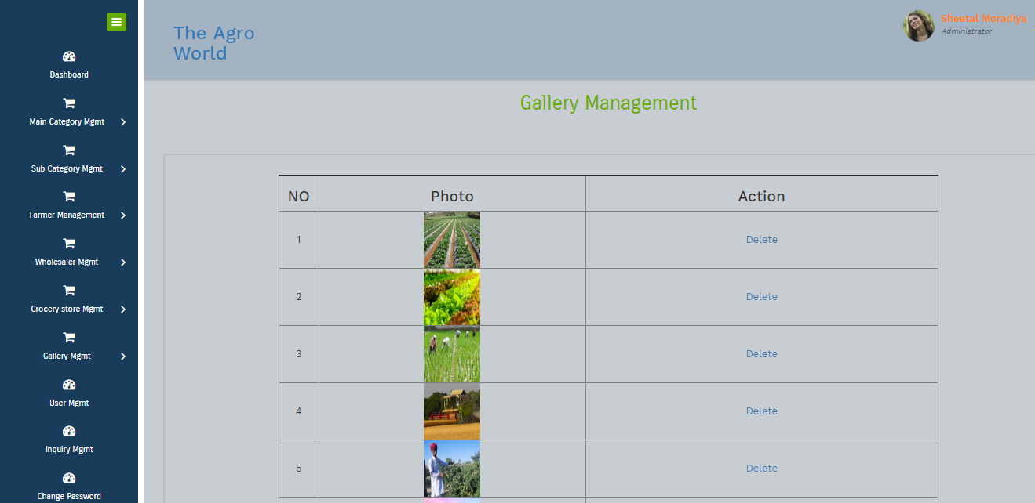

**Show Users**

It display user’s data which are registered in website.

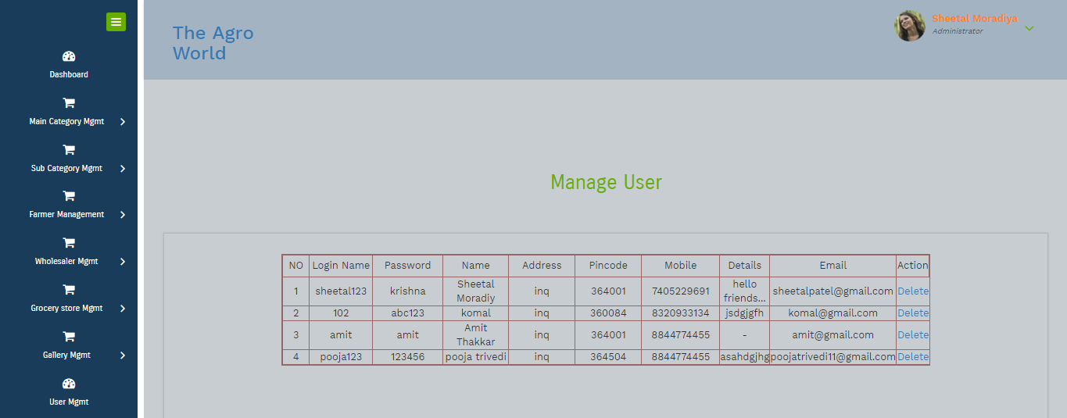

**Show Inquiry / Feedback**

It display inquiry or feedback which are send by users.

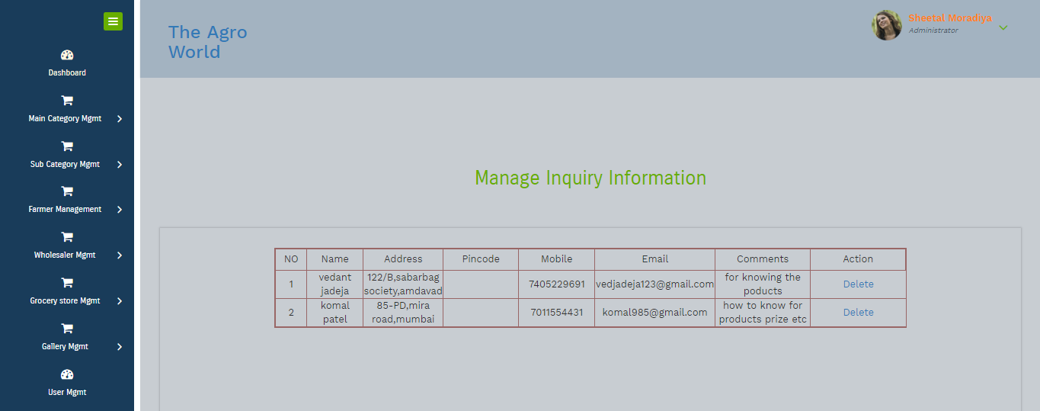

**Change Password**

Admin can able to change password.

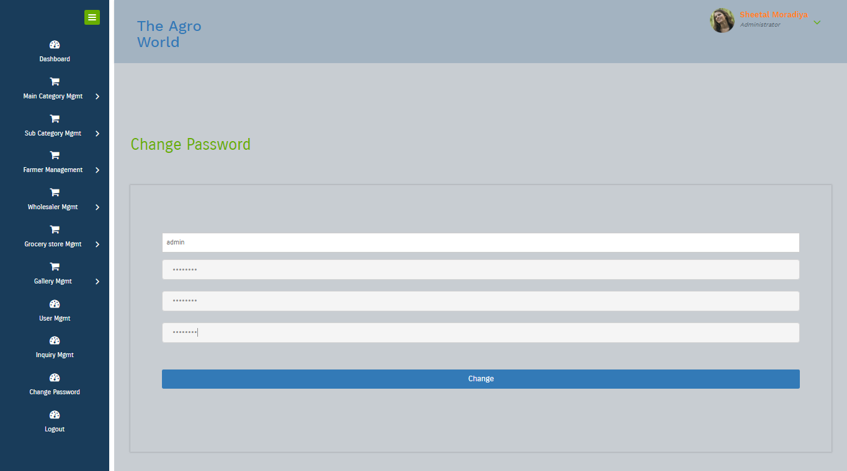

**Farmer**

**Farmer Login**

Farmer can able to login using login id and password which are available on Email or SMS.

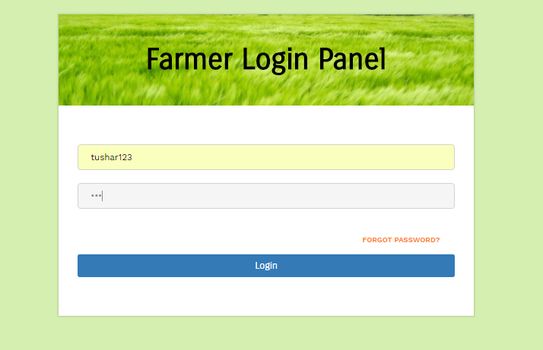

**Forgot Password - Farmer**

If Farmer can’t able to remember their login id or password then we provide forgot password option in which admin has to enter their email id or mobile number, login id and password sent to email or mobile.

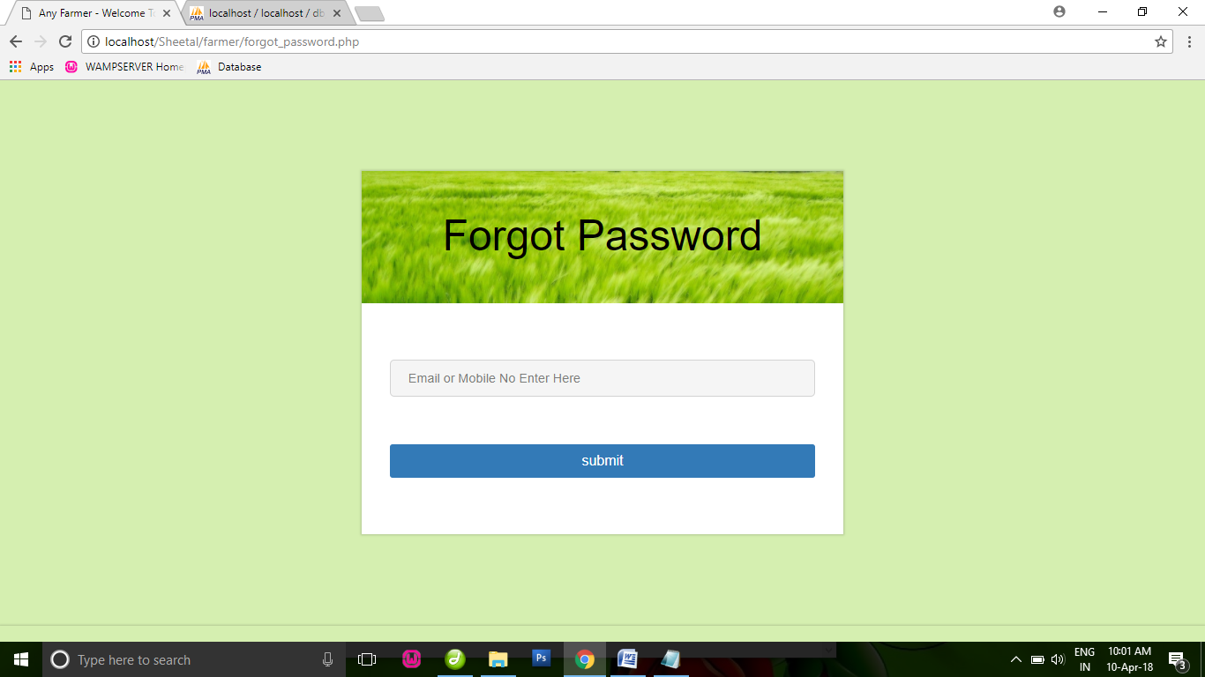

**Add Product**

Farmer can able to add their products for sell; these products are only display to wholesaler and wholesaler can able to purchase these products.

Also farmer can able to add products based on main and sub categories which are entered by admin.

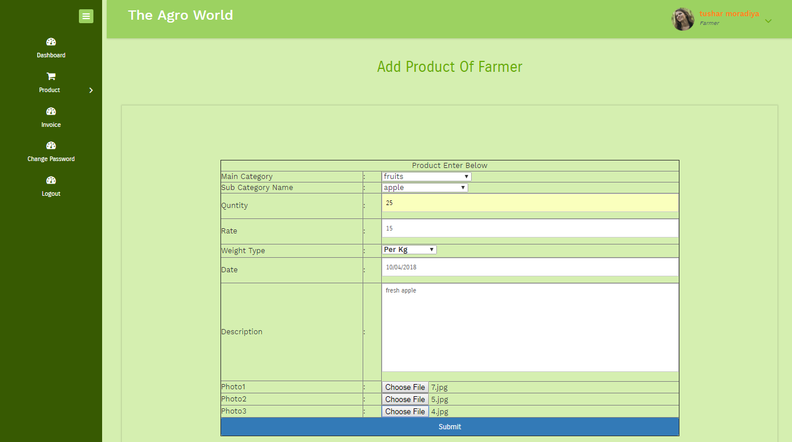

**Show Product**

Farmer can able to view, delete products which are entered by them.

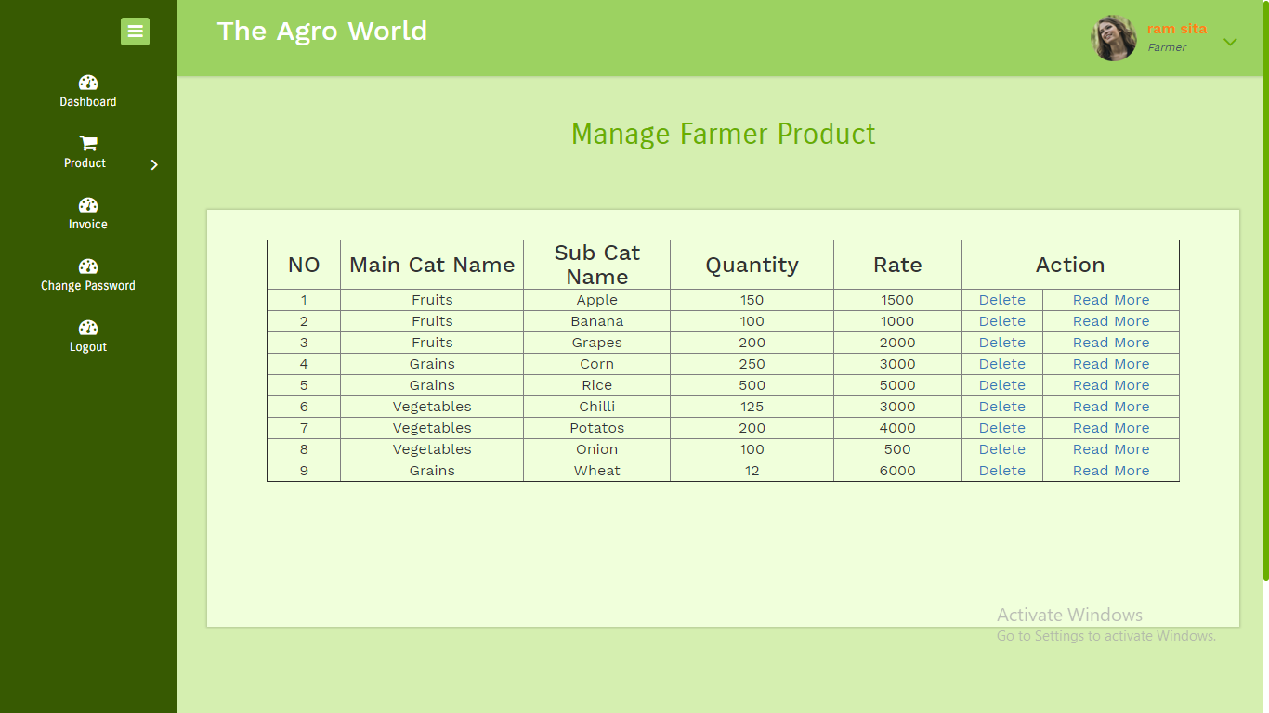

**Invoice**

Farmer can able to view and delete invoice, this invoice are generated from wholesaler, because only wholesaler can able to buy products from farmer.

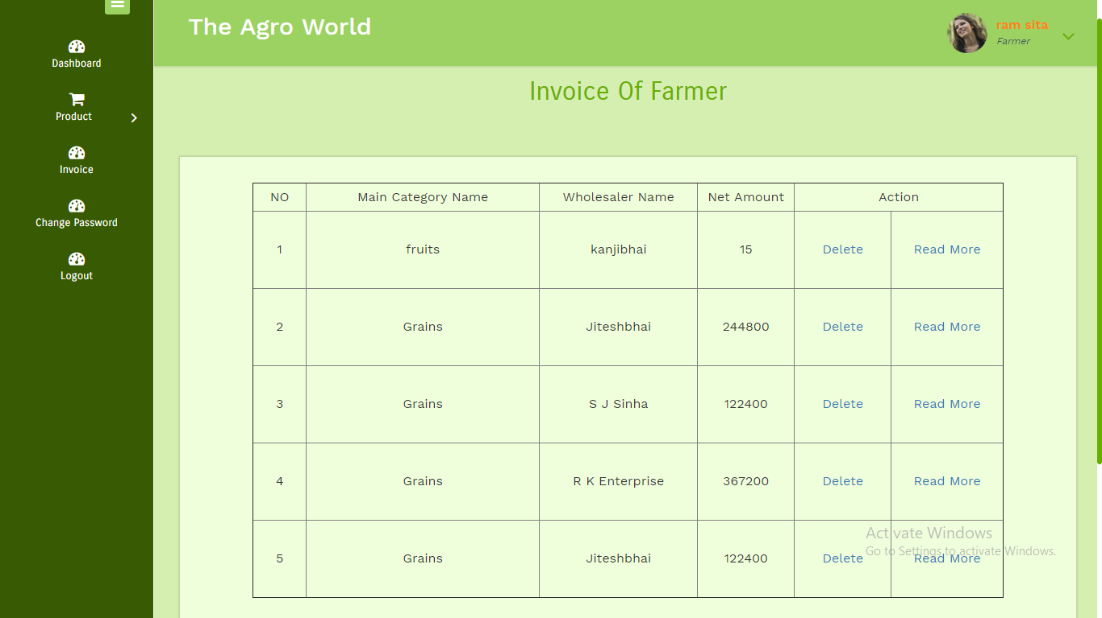

**Change Password**

Farmer can able to change their password.

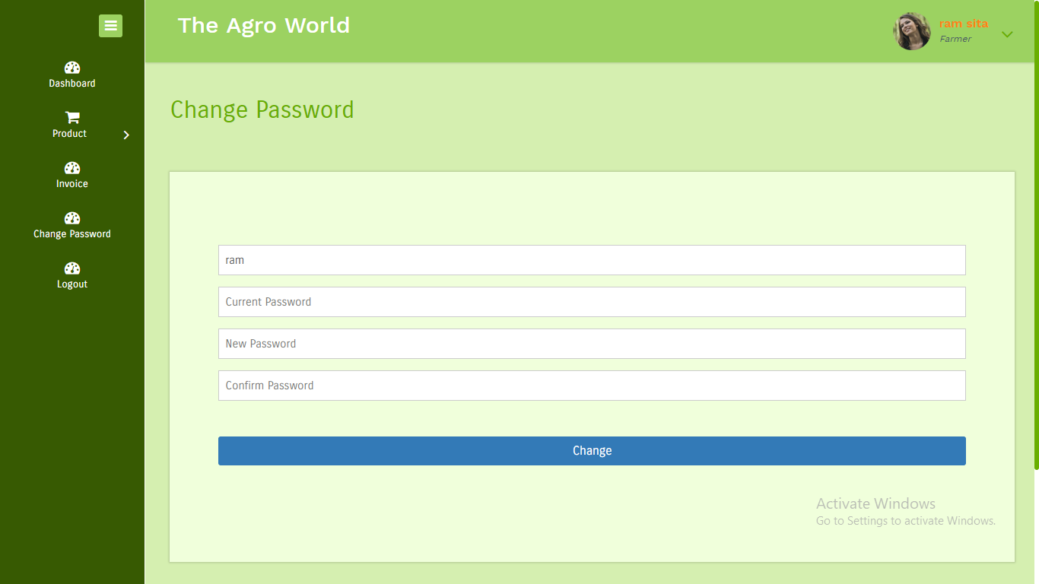

**Profile**

Farmer can able to view and edit their profile.

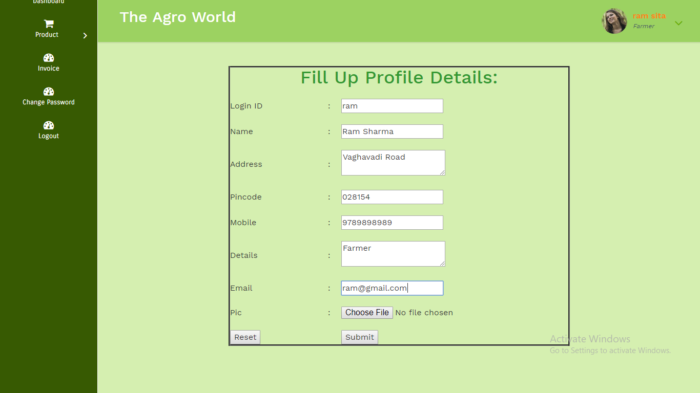

**Wholesaler**

**Login**

Wholesaler can able to login using login id and password which are available on Email or SMS.

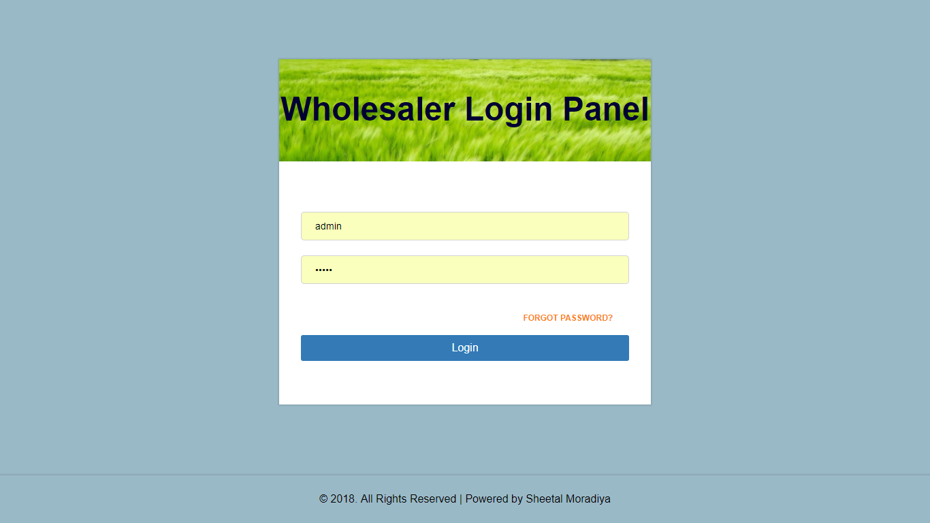

**Forgot Password**

If Wholesaler can’t able to remember their login id or password then we provide forgot password option in which admin has to enter their email id or mobile number, login id and password sent to email or mobile.

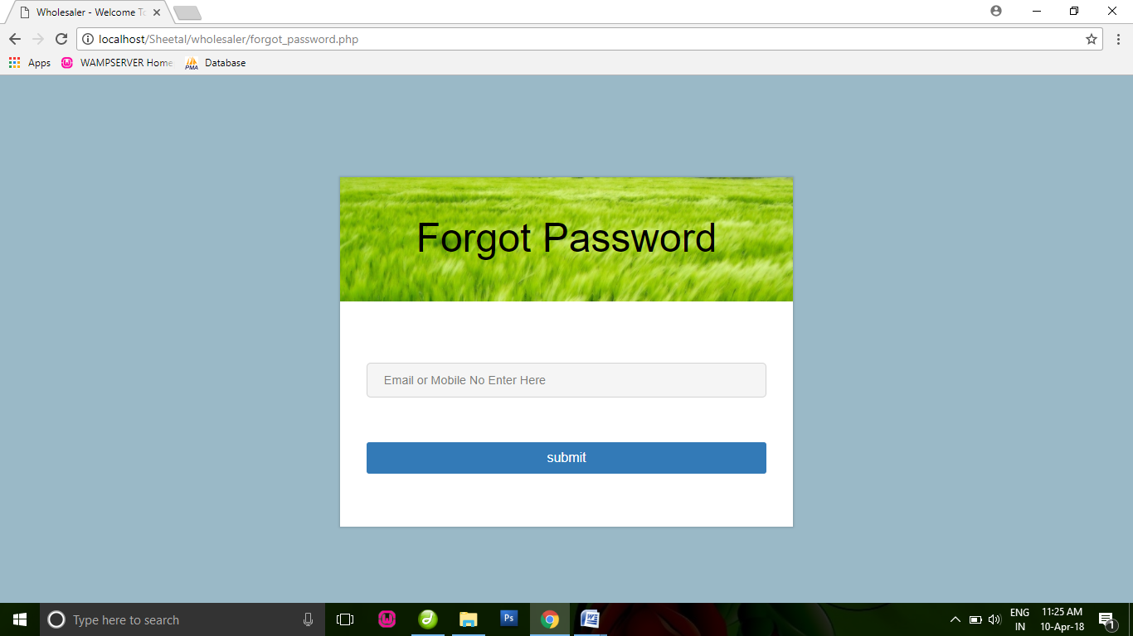

**Add Product**

Wholesaler can able to add their products for sell; these products are only display to wholesaler and wholesaler can able to purchase these products.

Also Wholesaler can able to add products based on main and sub categories which are entered by admin.

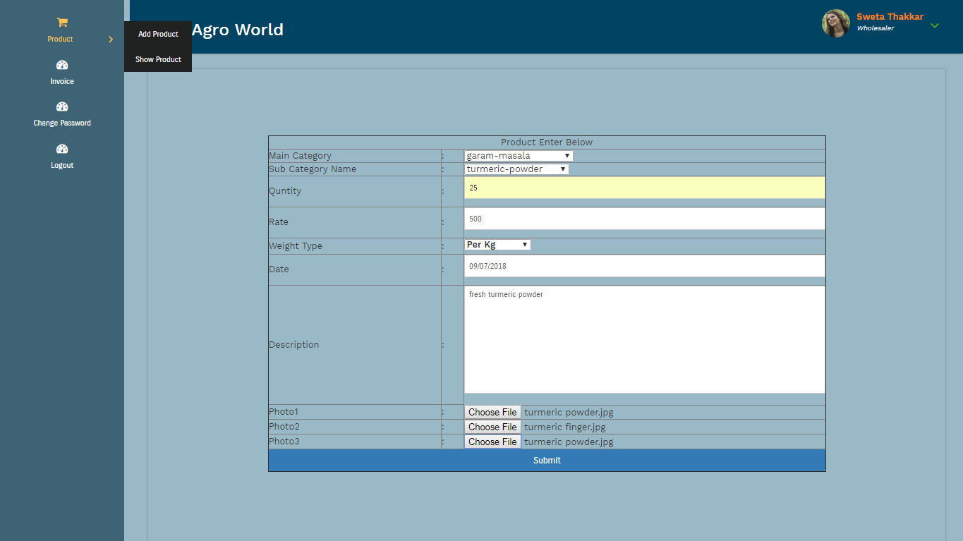

**Show Product**

Wholesaler can able to view, delete products which are entered by them.

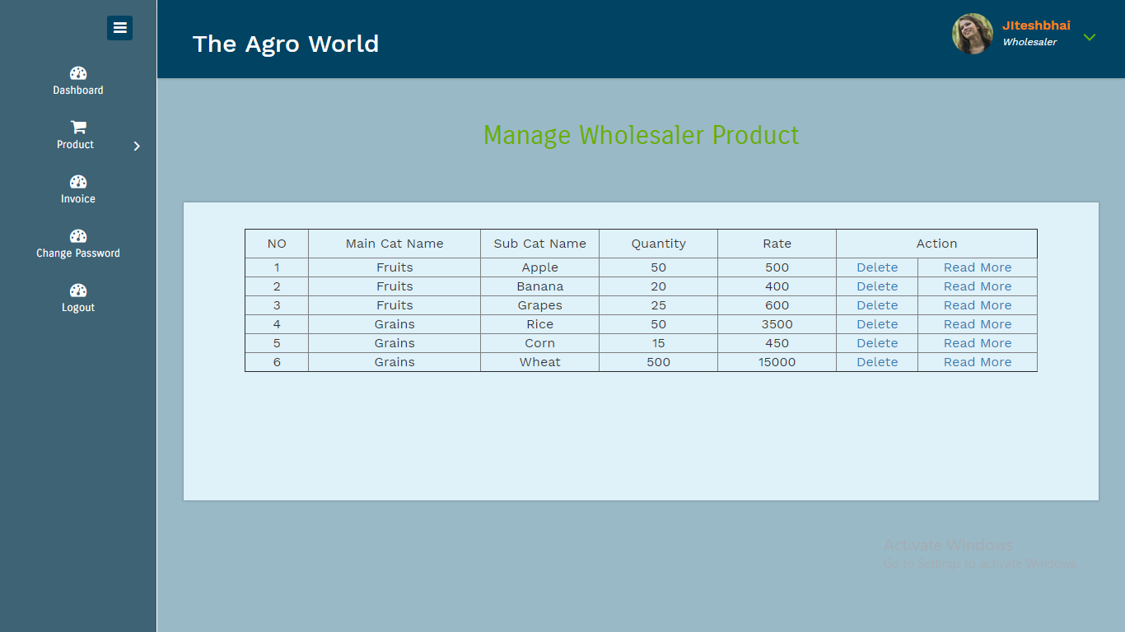

**Invoice**

Wholesaler can able to view and delete invoice, this invoice are generated from grocery store user, because only wholesaler can able to buy products from Wholesaler.

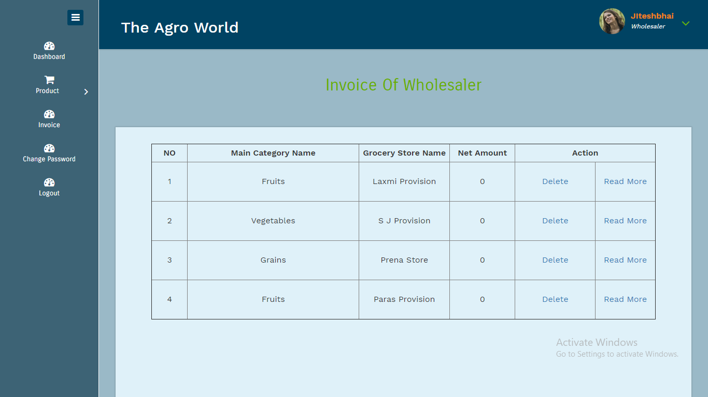

**Change Password**

Wholesaler can able to change their password.

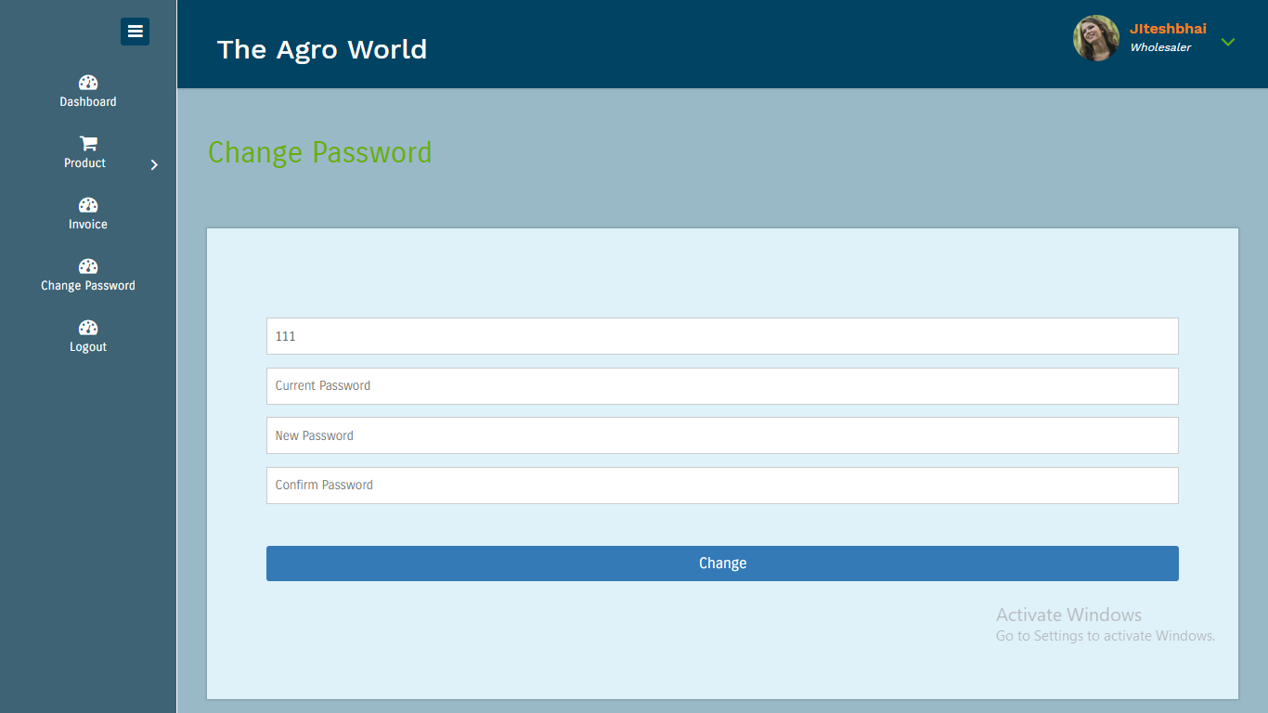

**Profile**

Wholesaler can able to view and edit their profile.

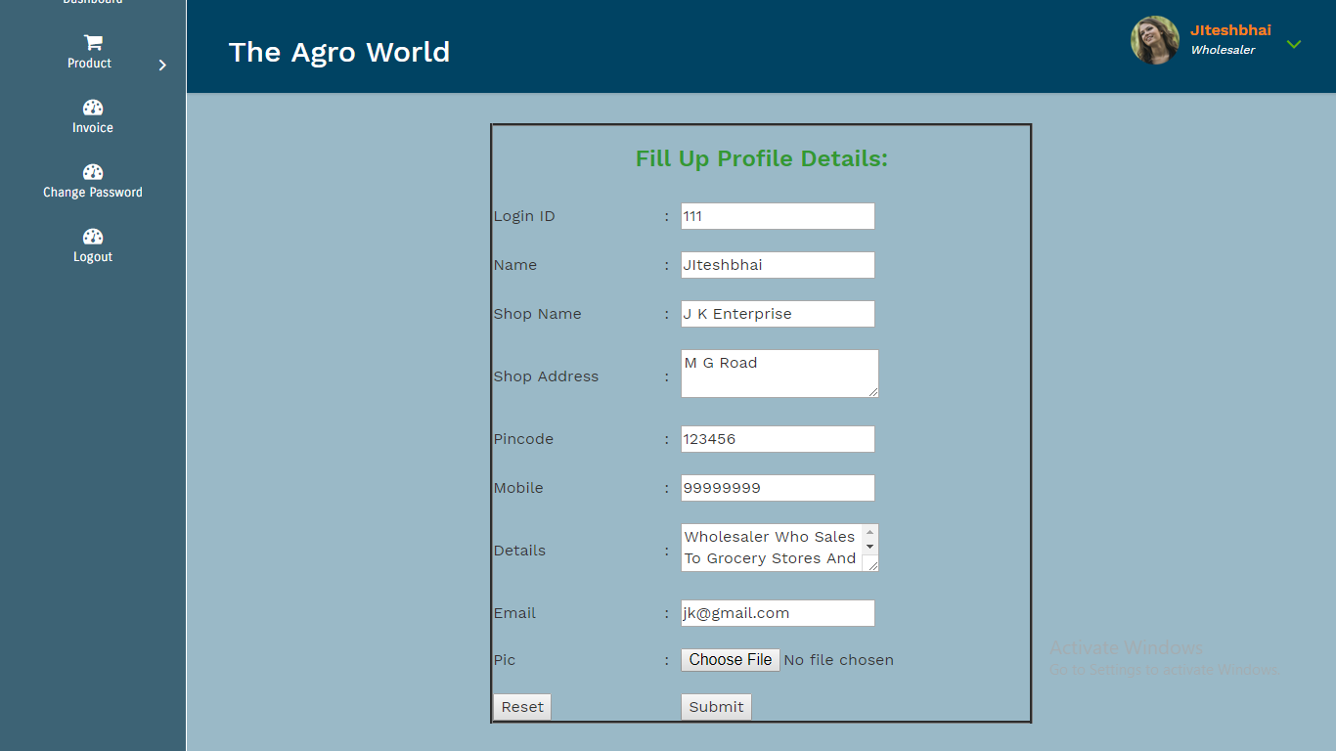

**Grocery Store**

**Grocery Store Login**

Grocery Store user can able to login using login id and password which are available on Email or SMS.

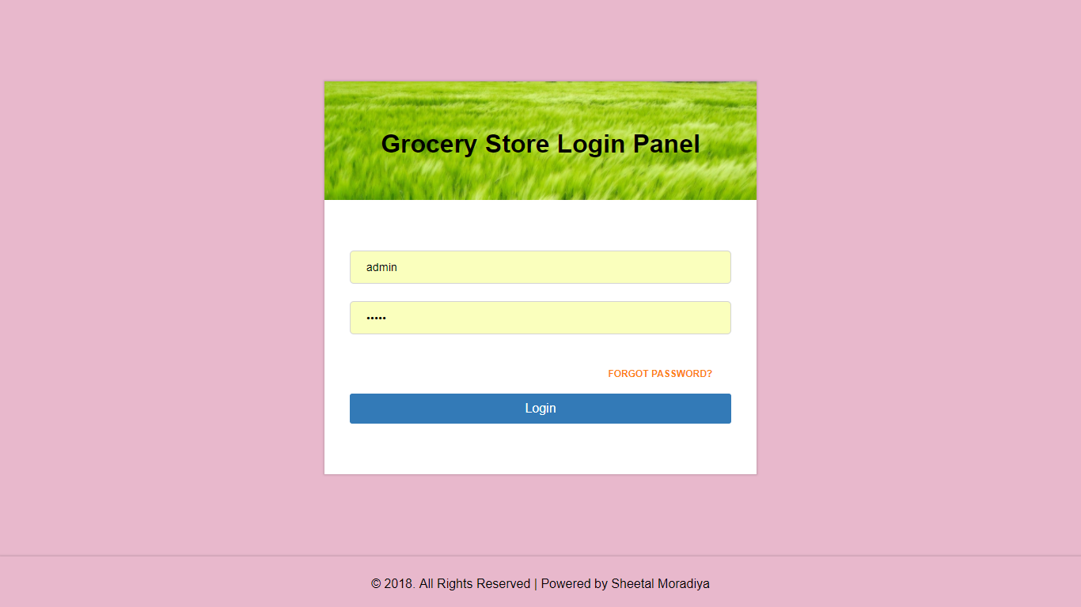

**Forgot Password - Grocery Store User**

If Grocery Store User can’t able to remember their login id or password then we provide forgot password option in which admin has to enter their email id or mobile number, login id and password sent to email or mobile.

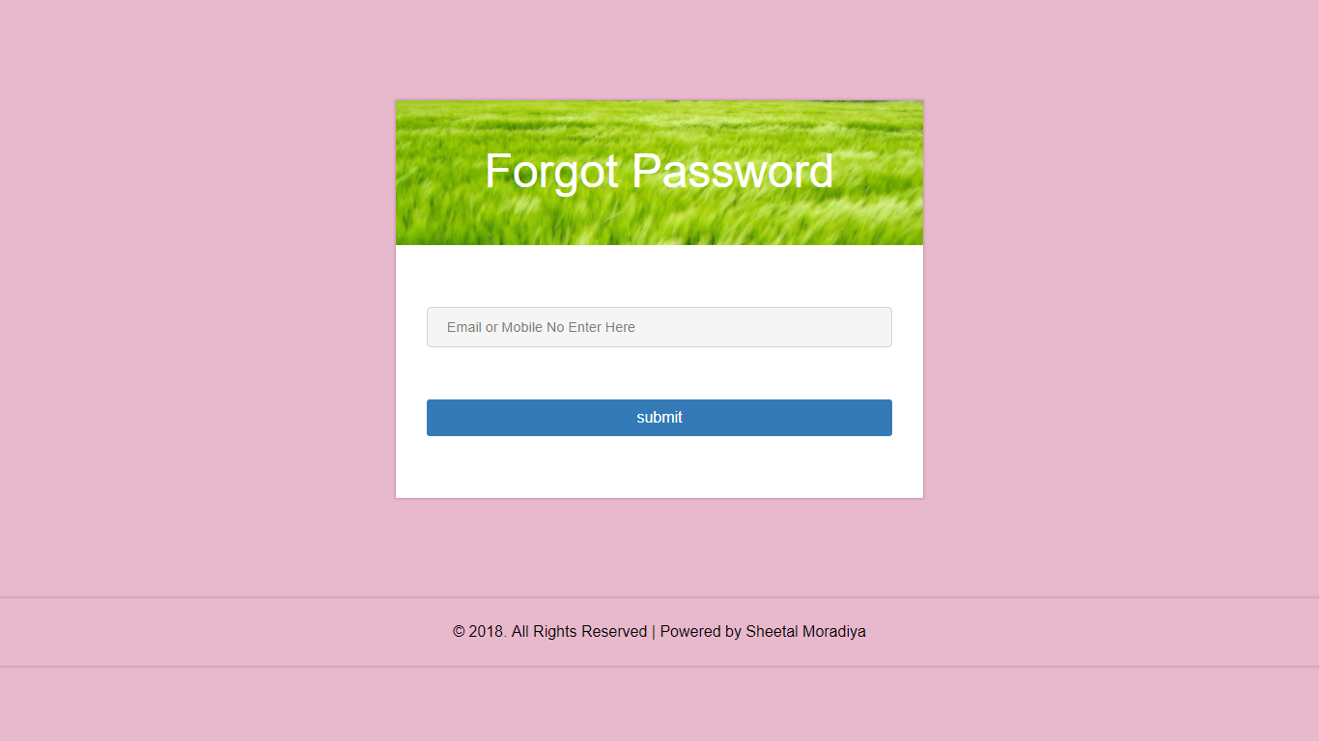

**Add Product**

Grocery Store User can able to add their products for sell; these products are only display to Users and they can able to purchase these products.

Also Grocery Store User can able to add products based on main and sub categories which are entered by admin.

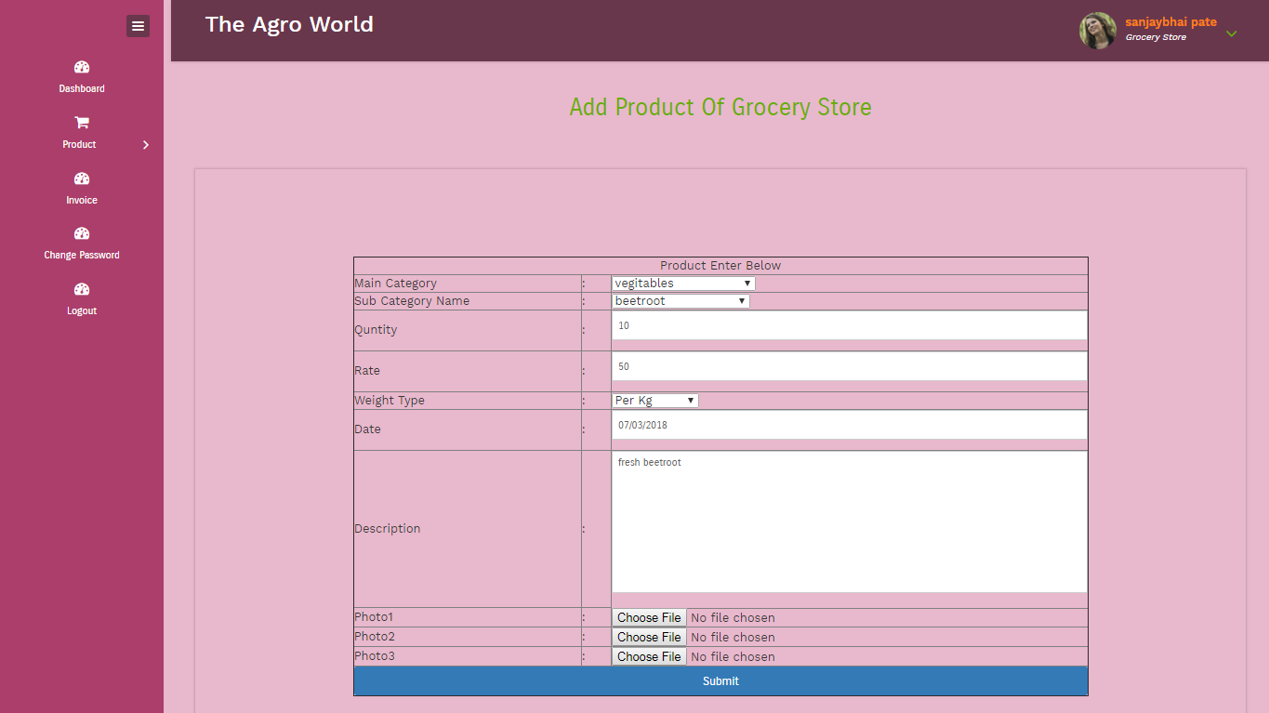

**Show Product of Grocery Store**

Grocery Store User can able to view, delete products which are entered by them.

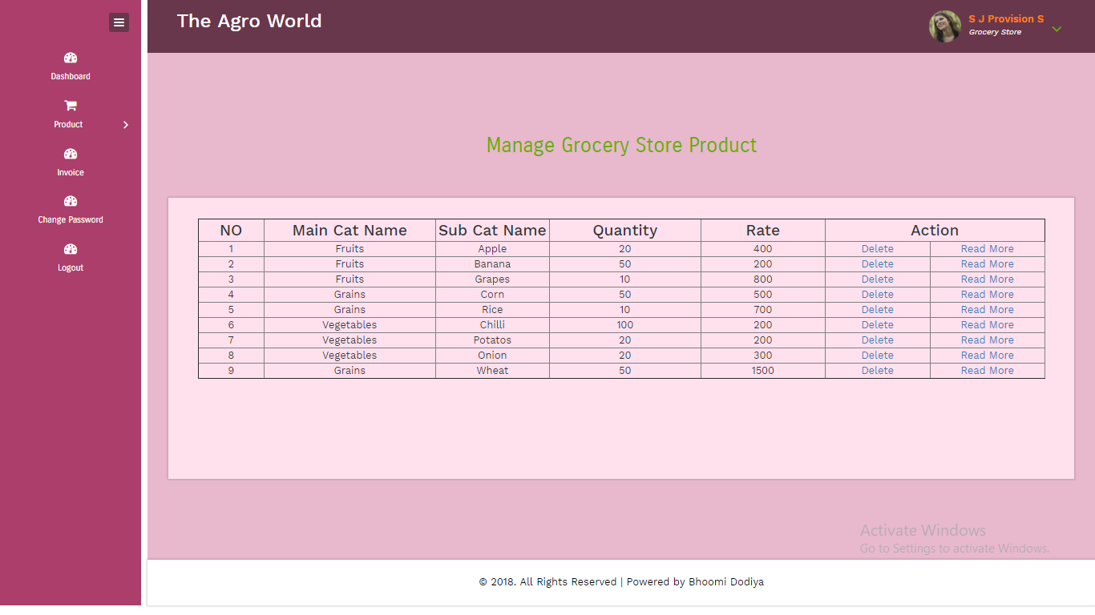

**Invoice of Grocery Store**

Grocery Store User can able to view and delete invoice, this invoice are generated from users, because only users can able to buy products from Grocery Store User.

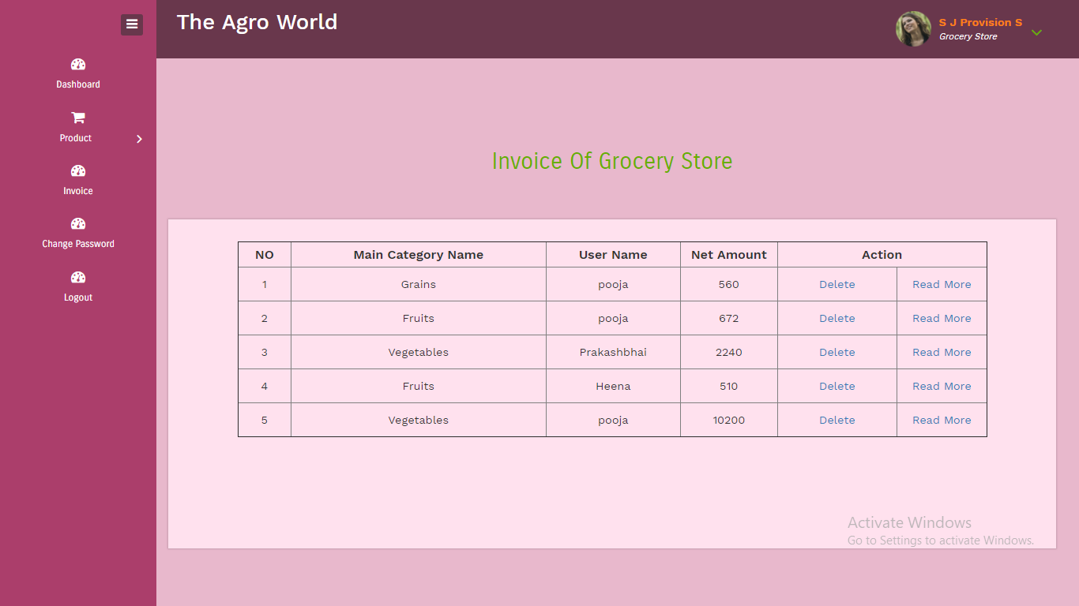

**Change Password of Grocery Store**

Grocery Store User can able to change their password.

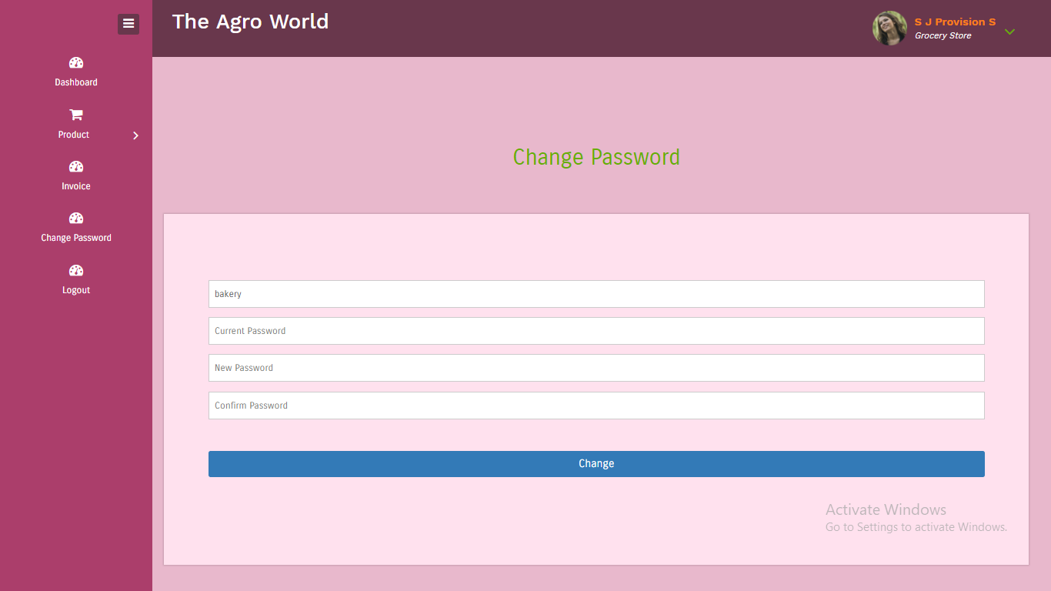

**Profile**

Grocery Store User can able to view and edit their profile.

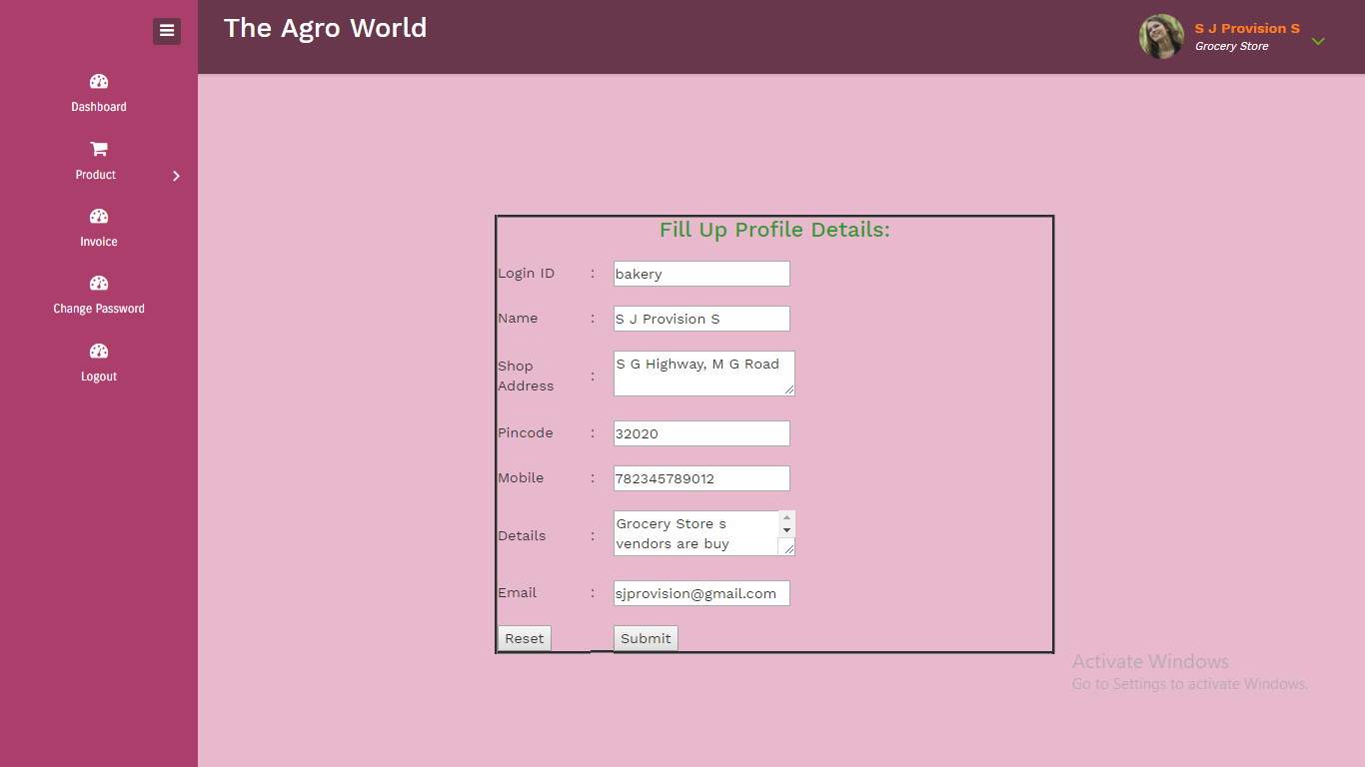

**USER SIDE**

**Home Page**

It displays Menu banner logo and basic details of website.

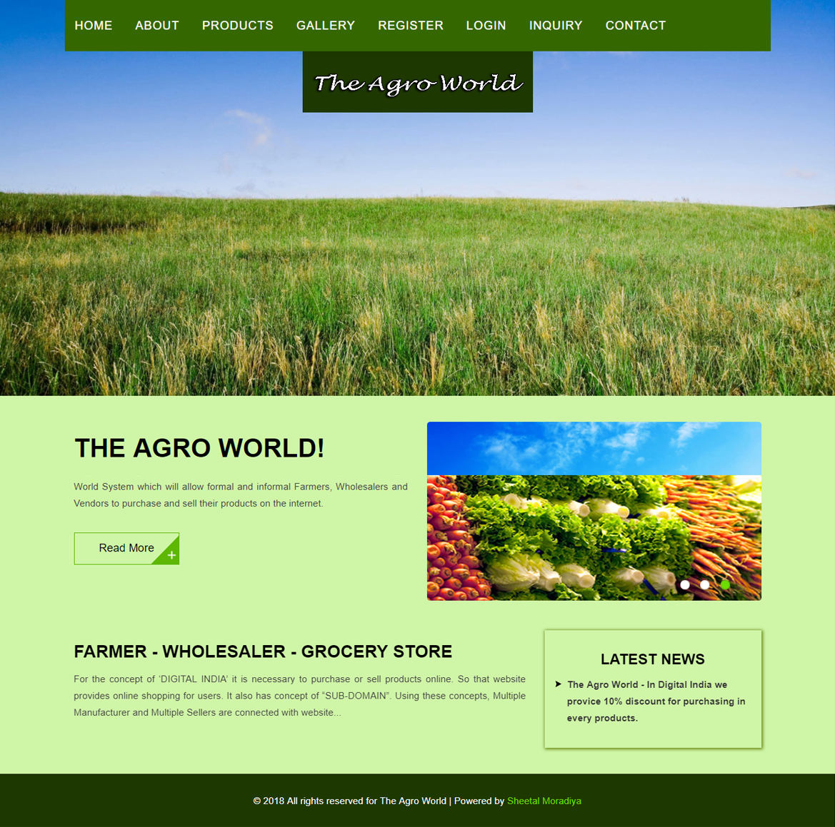

**About Us**

It display information about website



**Products**

It displays products categories wise which are uploaded by admin.

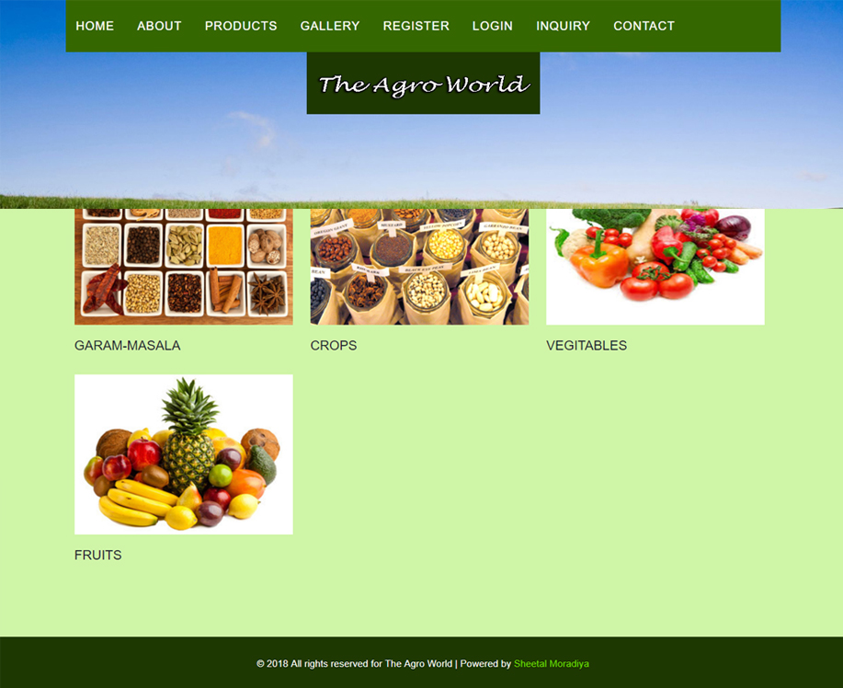

**Zoom Product Image**

User can able to click on image for zoom it.

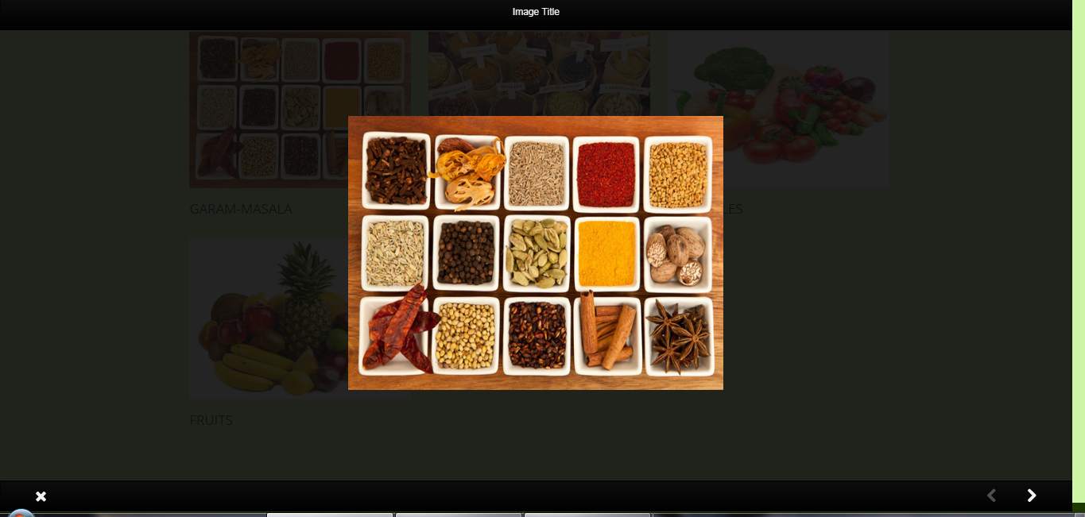

**Sub Product Information**

It display that data which are uploaded by admin.

**Product Details**

It display complete product details which are uploaded by farmer or wholesaler or grocery store.

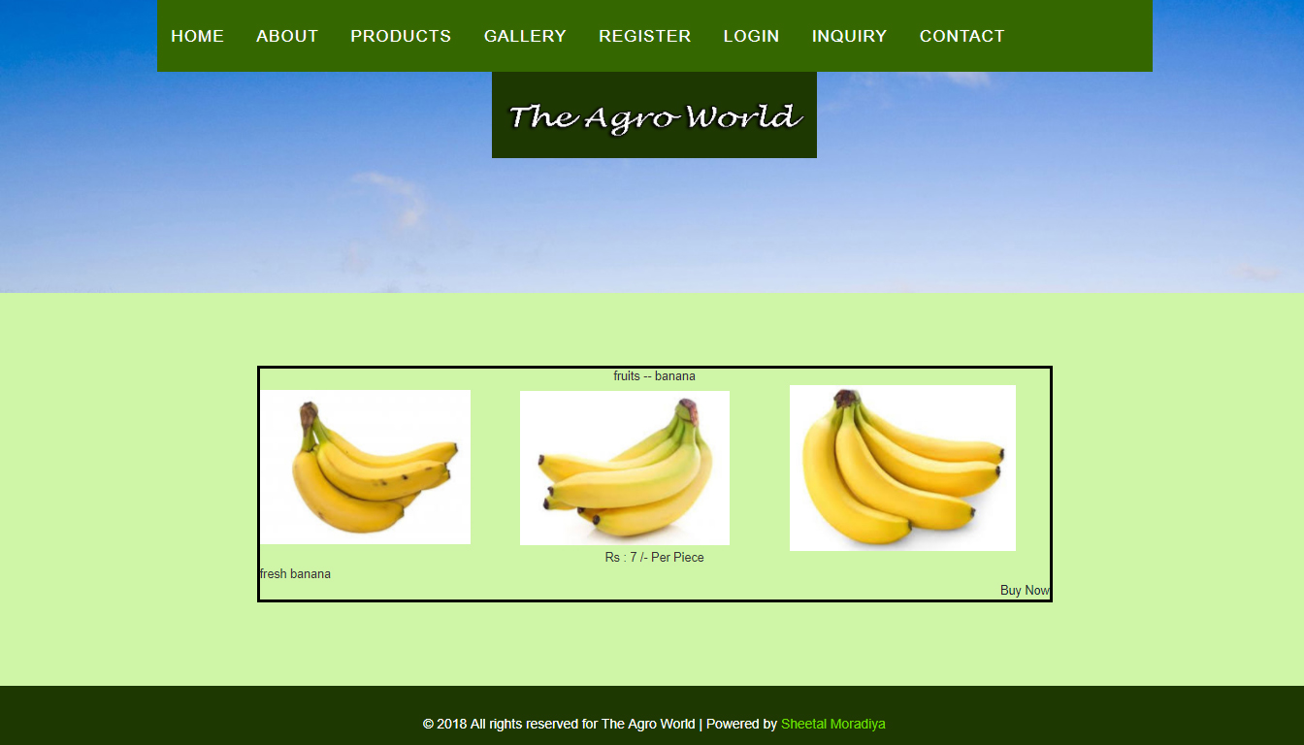

**User Login**

User can able to buy product by login must require.

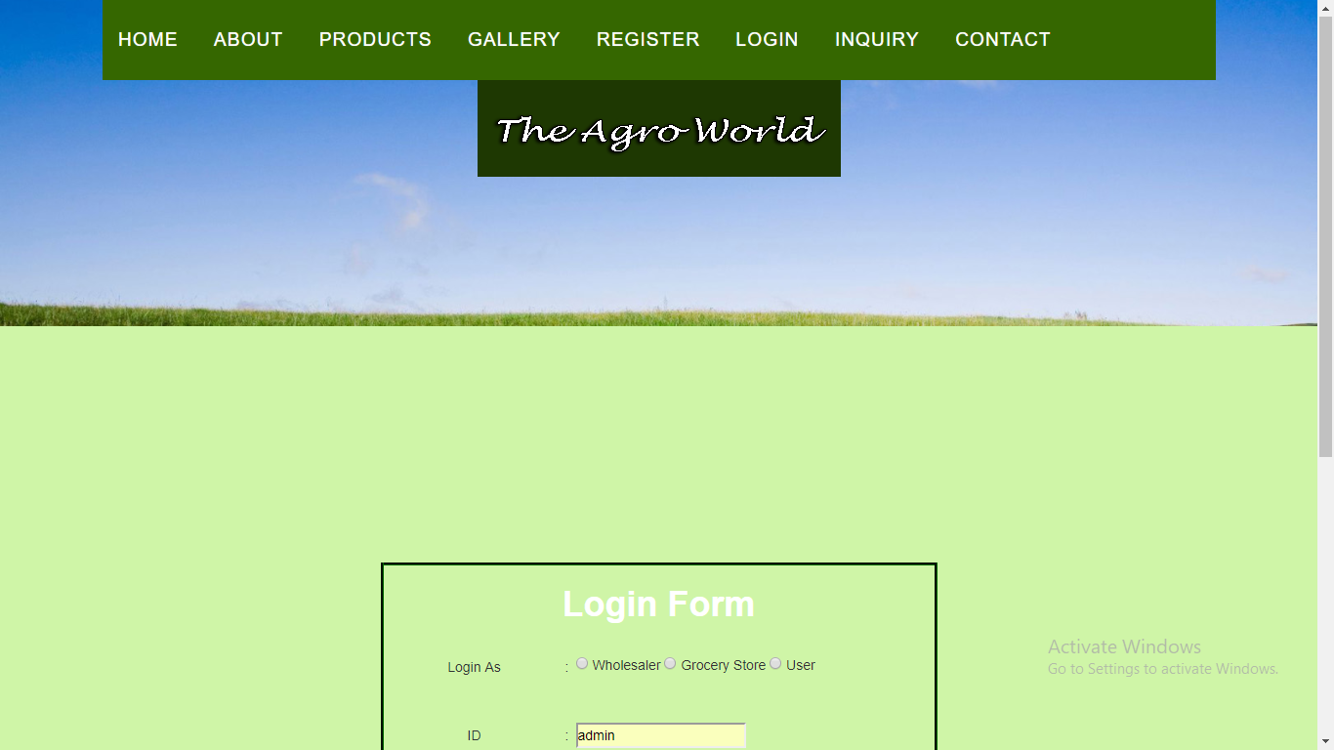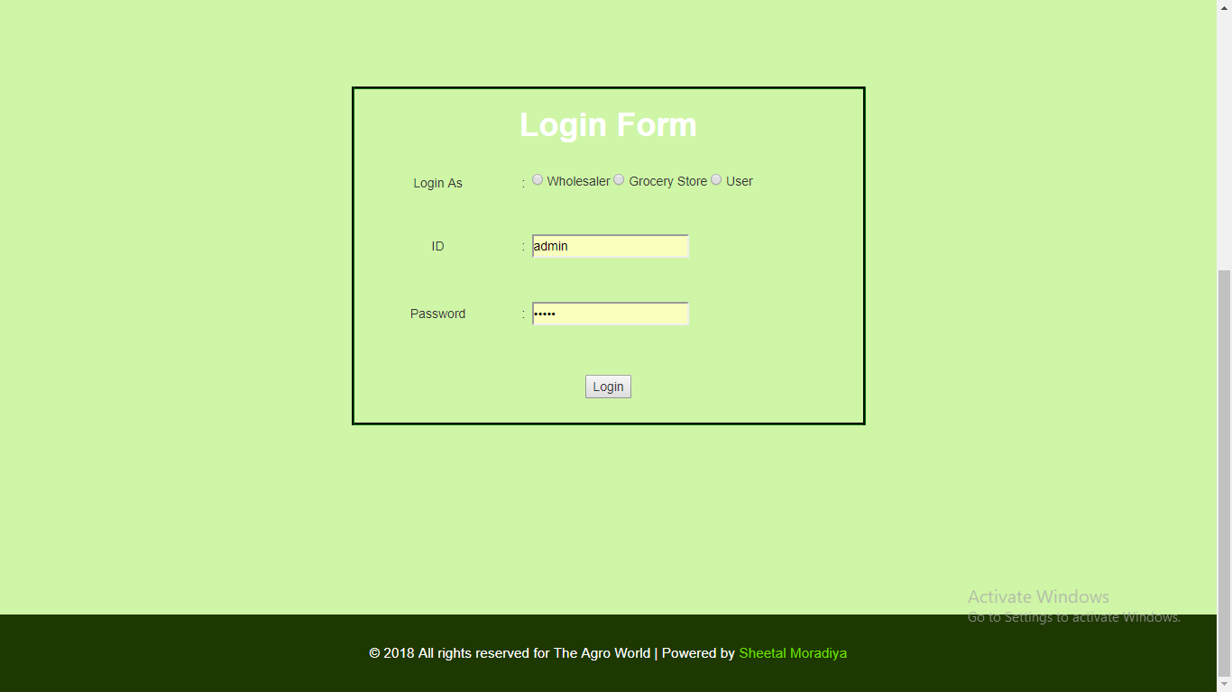

**User Profile**

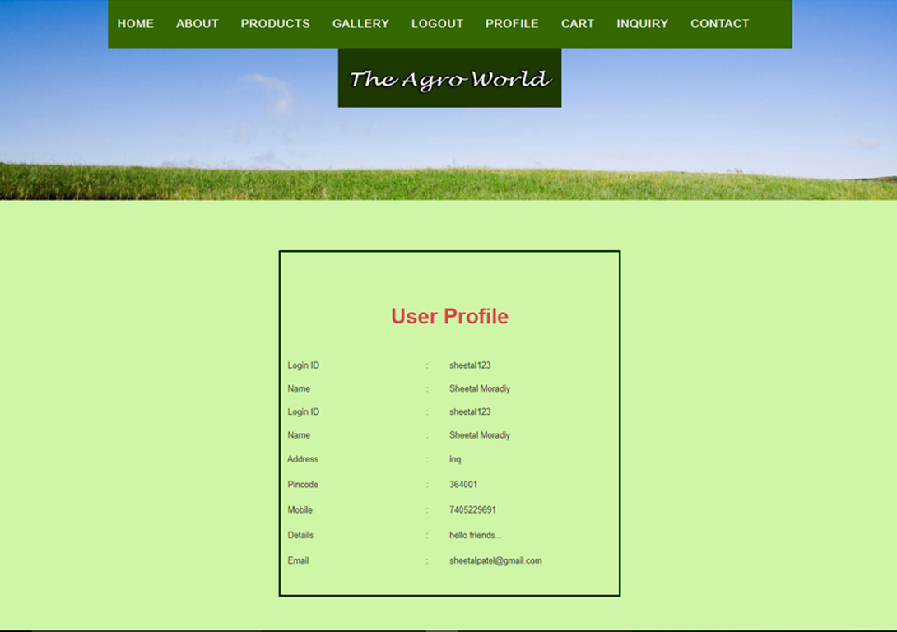

**Buy Product**

User can able to buy products (invoice)

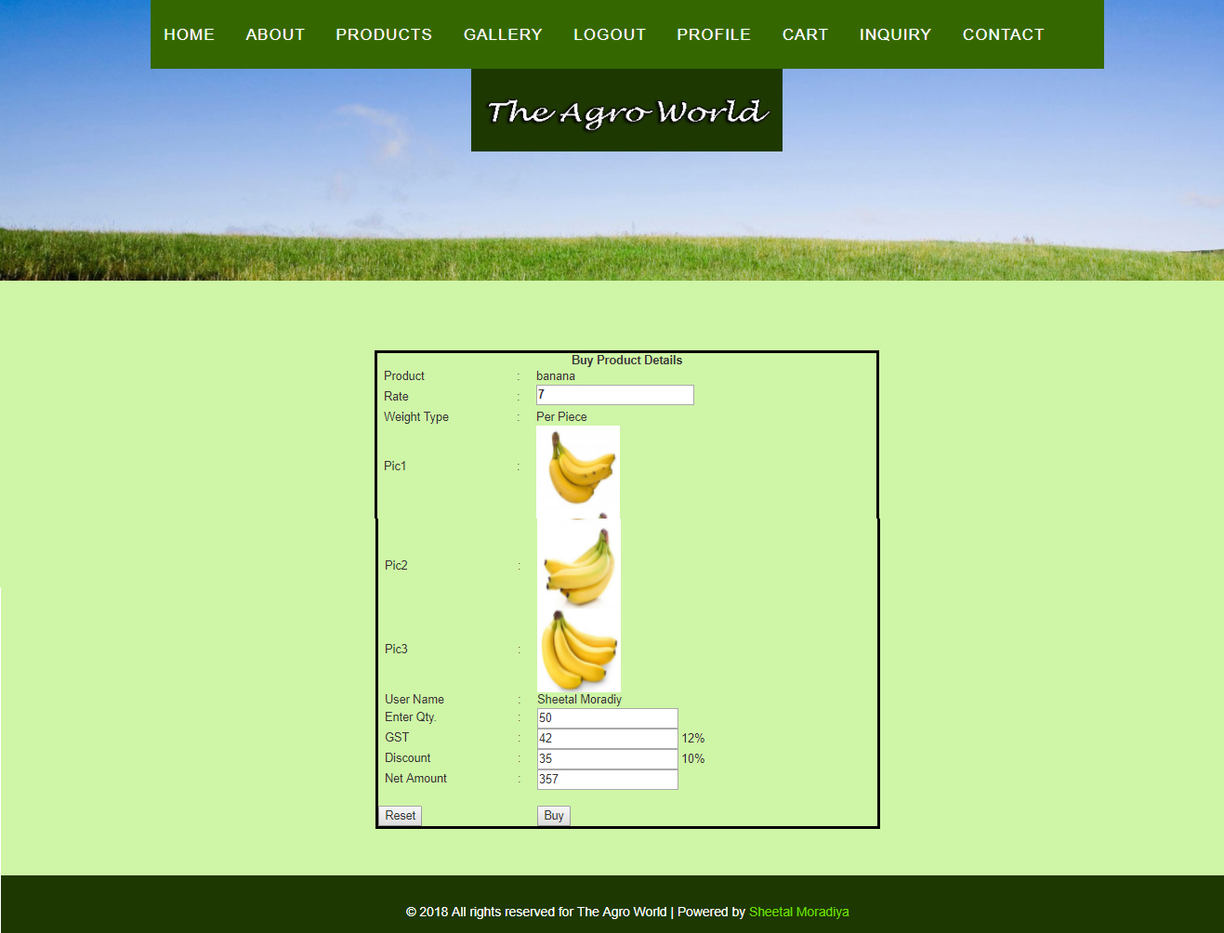

**Cart**

It display cart for user.

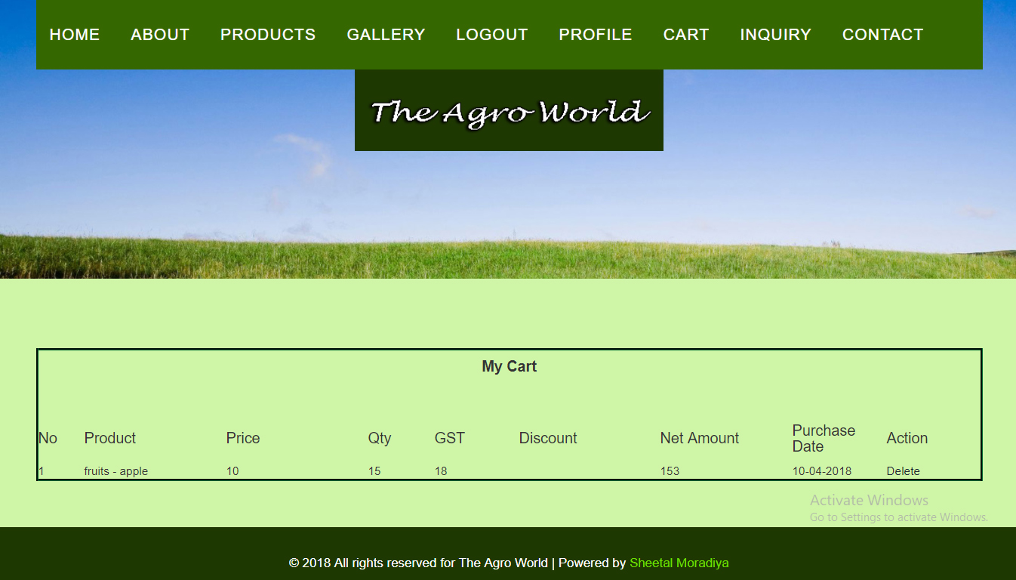

**Inquiry / Feedback**

User can able send feedback or inquiry

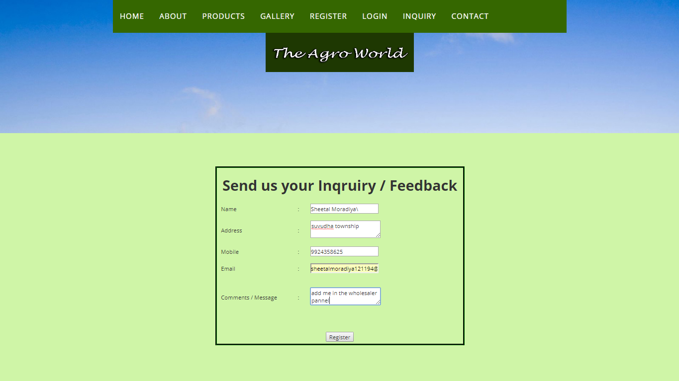

**Contact Details**

Display contact information of website owner.

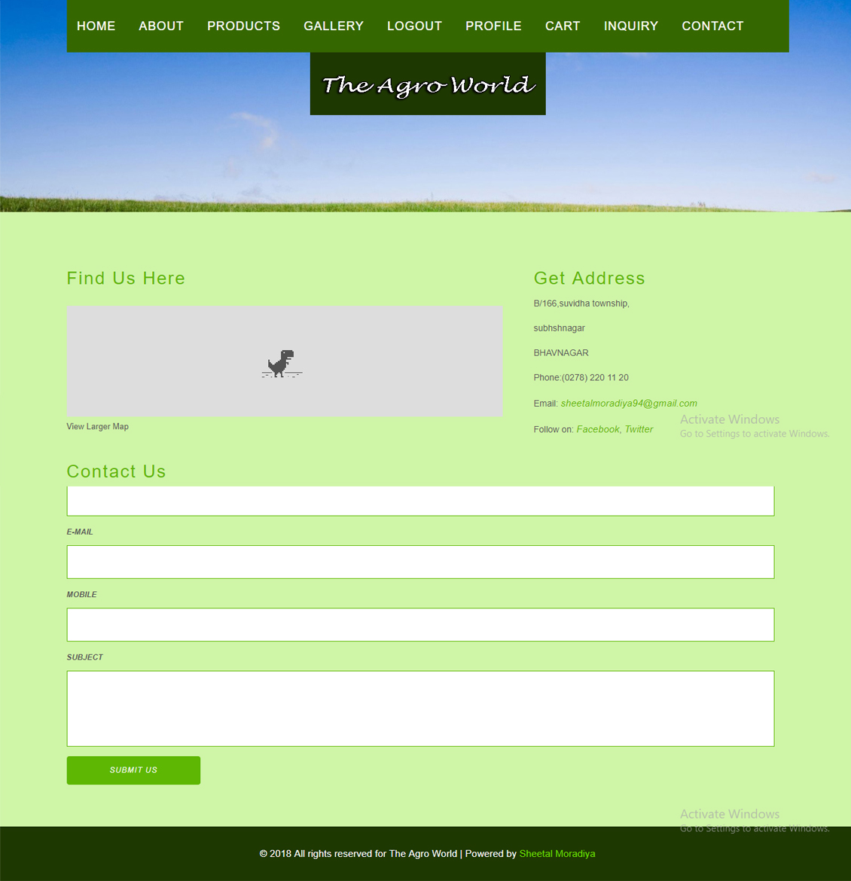

1. System Testing

System Testing:

The Software Development Life Cycle has many steps. From it one most useful step is testing. By testing the website we found the error or bug generate in it.

Testing process contains many types of phases. Testing can also be divided into various types. During the testing, if the program fails to run as anticipation, then it is called that the error has been occur during the development of the process.

Various types of testing phases are described as under:

Acceptance Testing

System Testing

Integration Testing

Unit Testing

1. Unit Testing:

Unit testing, a testing technique using which individual modules are tested to determine if there are any issues by the developer himself. It is concerned with functional correctness of the standalone modules.

The main aim is to isolate each unit of the system to identify, analyze and fix the defects.

1. Integration Testing:

Upon completion of unit testing, the units or modules are to be integrated which gives raise to integration testing. The purpose of integration testing is to verify the functional, performance, and reliability between the modules that are integrated.

1. System Testing:

System Testing (ST) is a black box testing technique performed to evaluate the complete system the system's compliance against specified requirements. In System testing, the functionalities of the system are tested from an end-to-end perspective.

1. Acceptance Testing:

Acceptance testing, a testing technique performed to determine whether or not the software system has met the requirement specifications. The main purpose of this test is to evaluate the system's compliance with the business requirements and verify if it is has met the required criteria for delivery to end users.

* + Bugs - User Side Purchase Product

|  |  |  |
| --- | --- | --- |
| **Sr. No.** | **Bugs** | **Result** |
| Bug 1 | Can’t Logout(Session can’t unset) | Solved |
| Bug 2 | Can’t directly transfer to product page from home page(transfer to view profile after login) | Solved |
| Bug 3 | Invoice can’t view in full size | Solved |

* + Bugs - Admin Side

|  |  |  |
| --- | --- | --- |
| **Sr. No.** | **Bugs** | **Result** |
| Bug 1 | Admin can’t able to login using id and password | Solved |
| Bug 2 | Farmer can’t Remove | Solved |
| Bug 3 | Sub product management not worked | Solved |

* + Bugs generated at Farmer User Side

|  |  |  |
| --- | --- | --- |
| **Sr. No.** | **Bugs** | **Result** |
| Bug 1 | Can’t display invoice | Solved |

* + Bugs generated at Grocery User side

|  |  |  |
| --- | --- | --- |
| **Sr. No.** | **Bugs** | **Result** |
| Bug 1 | Can’t able to purchase products from wholesaler. | Solved |
| Bug 2 | Didn’t display invoice | Solved |

1. Future Enhancement

Future Enhancement:

As opposed to my current development, a few more functionalities can be added to further expand the project.

1. In future mobile application could by done by us on requirement of user. A mobile integration could be done. Here the user of the site would be notified of any development of his request or any job opportunities on directly his mobile phone.
2. Right now, only mail sending is possible but in future requirement of User and Sub Admin with single & multiple message facility also available in our project.
3. In further requirement bill printing facility also integrated within it.
4. In future not only Indian but international companies and aspirants could be added to the site for a broader opportunity level for both the parties.
5. In future not only Indian but international companies and aspirants could be added to the site for a broader opportunity level for both the parties.
6. Conclusion

Conclusion:

In the beginning the project seemed to be just one another subject that we needed to pass in order to get a through my semester. But with passing time and with each passing day (even nights!), we found the development of this project became a great learning process.

The project followed each step of the system development lifecycle in order to create a system that was easy to use and learn. The knowledge of system analysis and design that we learnt in our second semester came in handy very much at this stage. Project also feels very special because the work of developing it as a series of predefined steps is not as easy as it seems. Many a times we felt tempted to just forget the rules and start coding immediately, but that is the most important lesson we mastered with the completion of this project that it is very much important to follow the SDLC to create a robust and accurate system.

Not only the project taught us how to analyze and code any software but it also managed to show us important resource management skills.

We had to complete the project in time and in budget. It was very important that we got proper information from the end-users in order to provide them with a fully functional and simple enough to understand system. That helped us to learn how to deal with people of different temperament and opinions.

All in all this entire project has prepared us fully for what we are going to face in the IT field in future. And we are very thankful for that.

1. Bibliography

Bibliography:

* **Web Resources**
  + [www.google.com](http://www.google.com)
  + [www.w3schools.com](http://www.w3schools.com)
  + www.agmarknet.gov.in
  + [www.wikipedia.com](http://www.wikipedia.com)
* **Books**
* PHP Manual
* Authors - StigSaetherBakken

Alexander Aulbach

EgenSchmid

Jim Winstead

Lars Torben Wilson

RasmusLerdorf

Andrei Zmievski

JouniAhto

* Publisher - PHP Documentation Group
* SAMS Teach Yourself PHP4 in 24 hours
* Author - Matt Zandstra
* Publisher – SAMS
* Pure JavaScript
* Authors - Jason Gillian,

Charlton Ting,

R. Allen Wyke

* Publisher –Techmedia